
RODOLFO V. FELICIANO MEMORIAL HIGH SCHOOL
San Pedro II, Magalang, Pampanga
CIPHER: Confluence of Institutional Price-structure, Histogram momentum, Exit timing, and Risk scaling in Bitcoin Trading, 2022 to 2026
Research Paper

By:
Pasok, Charles Gideon T.
Esguerra, Eireen Joy U.
Valerio, Euan Deign D.

Research Adviser:
Patrick Yambao

CIPHER: Confluence of Institutional Price-structure, Histogram momentum, Exit timing, and Risk scaling in Bitcoin Trading, 2022 to 2026
By: Pasok, Charles Gideon : Esguerra, Eireen Joy : Valerio, Euan Deign
Adviser: Patrick Yambao
School: Rodolfo V. Feliciano Memorial High School
Region III
ABSTRACT
This study tests a rule-based Bitcoin trading strategy against the two things an ordinary investor would otherwise do: buy a fixed amount every week, or buy once and hold. Every rule and parameter was set by eye from BTC/USDT 4-hour charts covering January 2018 to January 2022, then frozen before the reported window was measured. The strategy was run candle by candle over 8,767 four-hour candles from January 2022 to January 2026. It made 27 trades at a 70.37% win rate and a total net return of +30.31%, with a one-sided exact binomial p of 0.0261. A bootstrap of 10,000 resamples placed the 95% confidence interval on total return at [+5.9866%, +54.9866%], which excludes zero. Charging a realistic 0.20% round-trip cost cut the win rate to 62.96% and raised p to 0.1239, so the significance did not survive. From an equal $10,000 start, weekly buying reached $22,312.94 against the strategy's $13,417.77, a clear loss on final value, although the strategy held a position only 2.63% of the time. Directing 10%, 20%, and 30% of weekly contributions into the strategy raised the Sharpe ratio from 0.556 to 0.637 and made maximum drawdown shallower, from −27.85% to −23.18%. A forward test from January to July 2026 returned −3.45% over four trades. Two pre-registered follow-up analyses were added. Switching off any one of the four indicator gates lowered average return per trade in both test windows, but no difference survived a Holm correction for multiple comparisons. On 1-hour candles the unchanged rules made 31 trades and lost 0.18% per trade after costs (one-sided p = 0.696), so a faster timeframe did not keep the edge. One data-leakage bug was found during verification and fixed. Costs decide the verdict.
Keywords: Bitcoin, algorithmic trading, backtesting, dollar-cost averaging, Smart Money Concepts, technical analysis

Table of Contents

Introduction………………………………………………………………………………………..6
Significance of the Study………………………………………………………………………...13
Statement of the Problem………………………………………………………………….13
Framework………………………………………………………………………………………. 16
A. Research Design……………………………………………………………………….. 16
B. Materials and Sources…………………………………………………………………..17
C. Variables………………………………………………………………………………..19
D. Strategy Formulas……………………………………………………………………...20
E. Portfolio Construction and Contribution Schedule…………………………………….27
F. Data Analysis…………………………………………………………………………...28
Findings…………………………………………………………………………………………. 33
Answers to SOP 1 and Hypotheses H₀₁ and H₁₁………………………………………….. 33
Answers to SOP 2………………………………………………………………………… 39
Answers to SOP 3 and Hypotheses H₀₂ and H₁₂………………………………………….. 41
Answers to SOP 4 and Hypotheses H₀₃ and H₁₃………………………………………….. 43
Answers to SOP 5 and Hypotheses H₀₄ and H₁₄………………………………………….. 46
Conclusions……………………………………………………………………………………...47
Limitations………………………………………………………………………………... 50
Delimitations……………………………………………………………………………… 52
Summary and Conclusion………………………………………………………………… 53
References……………………………………………………………………………………….55
Appendix A……………………………………………………………………………………...58
Statistical Provenance of Every Reported Number………………………………………. 58
Appendix B……………………………………………………………………………………… 62
Source Form of Every Formula Written for This Study………………………………….. 62
Appendix C……………………………………………………………………………………… 63
Complete Trade Log for the Primary Window……………………………………………. 63
Appendix D……………………………………………………………………………………...66
Recomputing Every Number by Hand……………………………………………………. 66

Introduction
Money has moved online over the last thirty years. Cheaper phones and digital payments have closed much of the gap between ordinary people and financial services. The World Bank looked at 123 economies and found 76% of adults had a formal financial account by 2021, up from 51% in 2011. Most of that growth came from mobile money and e-wallets in developing countries (Demirgüç-Kunt et al., 2022). For many people these tools are not an add-on to a bank. They are the only bank they have.
Cryptocurrency is one of the biggest products of this shift. A cryptocurrency is a digital asset whose ownership is recorded on a blockchain, a shared public ledger kept by many computers instead of one bank. People can trade these assets directly, with no bank or broker in between, so all a person needs is a phone and an internet connection (Schär, 2021). In places like Magalang, Pampanga, where bank branches are few, crypto platforms are often a person's first door into global markets.
Young people are a large part of this shift, and many are learning about money by putting it to work. In the United States, a 2022 survey of adults aged 18 to 25 found that 56% already held investments. Among those investors, 55% owned cryptocurrency and 41% owned individual stocks, and nearly half said social media was their main source of investing information (FINRA Investor Education Foundation & CFA Institute, 2023). The same link between knowledge and investing shows up among Filipinos. In a survey of 384 college students in Metro Manila, financial knowledge was the only significant predictor of stock market investing (Arena et al., 2023). Among 435 millennial workers in Makati, higher financial literacy went with greater acceptance of cryptocurrency (Magbitang et al., 2023).
Bitcoin launched in 2009 as the first fully decentralized cryptocurrency and is still the most traded by value and volume (Nakamoto, 2008). It trades every hour of every day. It has no circuit breakers to pause it, and no central bank or company earnings behind it. That makes its price swings bigger than most other assets. Those swings are both the main risk and the main opportunity.
When a very large buyer or seller pushes price hard in one direction, it leaves a mark on the chart. There is usually a price area where the large position was built before the move began. Researchers call these areas Order Blocks (Bessembinder et al., 2009). Large traders split big orders into pieces and time them, which moves both resting orders and short-term price (Brolley & Cimon, 2020; Díaz & Escribano, 2020). Smart Money Concepts, the trading framework this study borrows from, is built on the same idea (Biais et al., 2005). The strategy here waits for price to return to one of these areas, checks whether the pullback is losing strength, then enters, sizes its risk to current volatility, and exits when momentum fades.
Bitcoin trades non-stop and reacts fast to sentiment, so company fundamentals are little help for short-term decisions. Traders use technical analysis instead: forecasting price from past price and volume (Svogun & Bazán-Palomino, 2022). It rests on two ideas. Price already reflects what the market knows. People repeat their behavior, so chart patterns repeat too (Fang et al., 2014). Technical rules have shown real predictive value in liquid crypto markets over short time frames (Corbet et al., 2019).
This study combines three families of tools. Each one answers a different question about the same price series: which way is price likely to move, how hard is it moving, and where have large traders already acted.
The first is MACD, short for Moving Average Convergence Divergence. It compares a fast moving average to a slow one and plots the gap between them as a histogram. That histogram shows whether momentum is building or fading (Chong & Ng, 2008). MACD does not predict a reversal. It reports current momentum. Chong and Ng (2008) tested MACD on 60 years of London Stock Exchange data and found it produced returns higher than a simple buy-and-hold approach in most of the cases they tested. Navarro and Navarro (2023) tested MACD on 178 Philippine stocks over a 12-year period. Under the standard settings, about 35% of those stocks were consistently profitable under MACD; a faster, alternative setting raised that to about 51%. Results like these move a lot with the market and the settings used, which is part of why this study measures MACD's own contribution directly instead of assuming it. Here the slope of the MACD histogram is the momentum check: below zero but rising favors a long entry, and above zero but falling favors a short entry.
The second is the KDJ oscillator, which moves within a fixed range, so readings near the top or bottom flag unusual conditions. KDJ is a stochastic oscillator with a third line, J, added to make disagreements between price and momentum easier to see. It starts from the Raw Stochastic Value, which measures where the current close sits inside the high-to-low range of recent candles. K and D smooth that value, and J is three times K minus two times D, which makes it react faster than either (Wu & Diao, 2015). Wu and Diao (2015) tested MACD, RSI, and KDJ together on eight years of Shanghai and Shenzhen stock data and found the combination gave a better chance of predicting short-term price moves than the market period alone would explain. Dai et al. (2020) found that KDJ and related indicators produced stock-return forecasts that were statistically and economically significant, in-sample and out-of-sample. Neither paper builds a full entry-and-exit trading strategy around KDJ, which is part of the gap this study addresses.
This study uses two separate KDJ calculations, and telling them apart matters. The first is one fixed nine-period series computed across the whole dataset. It decides whether to enter a trade and never changes from trade to trade. The second runs only after a trade is open, to time one kind of exit. Only this second one has a window length that adapts, and it adapts to the number of candles between the Order Block that triggered the trade and the entry candle. Across the 27 trades that window ranged from 14 to 439 candles, with a middle value of 74. This ties exit timing to the structure that caused the trade while keeping the entry decision on a fixed footing.
The third tool measures how hard price is moving, not which way. The Average True Range, introduced by Wilder (1978), does this. True range is the largest of three numbers: the current high minus the current low, the gap from the current high to the previous close, or the gap from the current low to the previous close. ATR averages that over a window and carries no bullish or bearish opinion, only a volatility reading. Here a 14-period ATR sets the stop-loss distance, the trailing exit, and one profit-taking exit, while a 200-period ATR gives a long-run volatility baseline used to filter market conditions and judge Order Blocks. Two windows mean risk settings scale with current conditions instead of sitting at fixed levels.
ATR does not appear in the headline return numbers the way MACD or KDJ do, because its job is not to call direction. It decides how much risk each trade carries once a trade is already justified by the other tools. This is also how ATR is used on real trading desks. A common rule is to risk the same dollar amount on every trade and let ATR set the position size, so a wider ATR means a smaller position and a narrower ATR means a larger one. Stop-loss distances are set the same way, as a multiple of ATR, so a stop sits wider in a volatile market and tighter in a calm one. That is the same logic this study applies to Bitcoin: keep risk per trade steady while everything else about the market changes.
None of these three tools accounts for the influence of very large participants. Smart Money Concepts addresses this by reading raw price structure for institutional footprints instead of statistical averages, on the premise that large entities engineer price moves to reach pools of resting orders and fill large positions before reversing (Bessembinder et al., 2009). Order Blocks are detected here at two levels, one with a 50-candle lookback for larger swings and one with a 5-candle lookback for smaller structure, and each is judged against five quality criteria defined in Section D.
Earlier research has tested MACD, KDJ, and other technical rules alone, or at most in pairs (Chong & Ng, 2008; Corbet et al., 2019; Lv et al., 2017). No published study tests MACD, an adaptive KDJ exit, a dual-ATR risk framework, and Order Block detection all together, in one backtest, on cryptocurrency. That is the real gap. It is not whether any one of these tools works; each has already been shown to work alone. The open question is what combining them does to the result, for better or worse, measured against the passive options an ordinary participant would otherwise use. This study fills that gap.
A strategy only matters next to what a person would otherwise do. For most retail participants the realistic alternative is not another algorithm. It is dollar-cost averaging, buying a fixed amount on a fixed schedule regardless of price, or one lump-sum purchase held without further action. Dollar-cost averaging is the default in the recurring-buy feature of most exchanges and savings apps, and it is the standard baseline researchers use when they study systematic retail investing (Finlay & Zorn, 2023). Constantinides (1979) showed it is suboptimal under standard expected-utility assumptions, because delaying investment gives up expected return. Statman (1995) argued it survives anyway because it answers behavioural needs, such as regret aversion and a desire for self-control, that an optimal policy does not. Theoretically weak but behaviourally dominant is exactly what makes it the right benchmark for a study aimed at ordinary participants. This paper therefore runs the strategy against weekly dollar-cost averaging and lump-sum buy-and-hold over the same window from the same starting capital, then asks the question closer to real use: not whether the strategy replaces a weekly buying plan, but whether putting part of that plan into the strategy improves it.
The design separates the period used to build the rules from the period used to test them. Every rule, parameter, and threshold was set by eye from BTC/USDT charts over January 2018 to January 2022, drawing on prior trading experience. That period was examined visually. It was never fed into a search, a sweep, or an optimizer, and no parameter was adjusted to improve a measured outcome. The primary findings come from January 2022 to January 2026, which the rules were not built against.
Two follow-up questions were added after those results were fixed. Each was written into a dated pre-registration file before any of its own numbers were computed. The first asks how much each of the four indicator gates contributes to the result. The second asks whether the same rules still work on 1-hour candles, which offer four times as many candles in the same period and could, in principle, give more trades. Both are answered in full in the Findings, under SOP 4 and SOP 5.

Significance of the Study
Access to financial services in the Philippines has grown far faster than participation in financial markets. Account ownership among Filipino adults rose from 29% in 2019 to 56% in 2021, driven mostly by e-money accounts, which rose from 8% to 36% (Bangko Sentral ng Pilipinas, 2022). Over the same two years, investment uptake, excluding pension contributions, fell from 15% to 10%. More Filipinos can reach a market than ever before. Fewer of them are actually invested in one.
That gap is what this study speaks to. Open, reproducible research on rule-based trading gives a first-time participant something better than a screenshot of somebody's returns: a full set of rules, the data they were tested on, and an honest account of where they failed. The work supports United Nations Sustainable Development Goal 8, on inclusive economic growth, by turning market participation into transparent, repeatable rules, and Goal 11, on inclusive and resilient communities, by contributing to the digital financial infrastructure residents already use (United Nations, 2015). Everything here is built from publicly available data and open-source tools, so it can be reproduced anywhere.

Statement of the Problem
Bitcoin is hard to forecast over short time frames. It trades 24 hours a day, moves sharply, and reacts to large institutional order flow, so ordinary analysis often misses directional signals before they appear. MACD and KDJ have each shown predictive value on their own. What has not been tested is what happens when those momentum tools are combined with volatility-based risk management and Order Block detection, all together, and how the result holds up against the passive options an ordinary participant would otherwise use.
This study seeks to answer:
1. How effectively does the combined MACD, KDJ, ATR, and Smart Money Concepts strategy predict short-term Bitcoin price movements, as measured by win rate, total net return, and average return per trade?
2. How does the strategy compare against the two passive alternatives an ordinary participant would realistically use, namely weekly dollar-cost averaging into Bitcoin and a single lump-sum purchase held to the end of the window, when all three are started from identical capital and measured on total return, Sharpe ratio, maximum drawdown, and time in market?
3. Does directing a share of new weekly contributions into the strategy improve the risk-adjusted profile of an otherwise ordinary Bitcoin dollar-cost-averaging plan, and if so, how does that improvement behave as the allocated share rises?
4. How much does each of the four indicator gates, namely the MACD histogram, KDJ, K-acceleration, and ATR-regime gates, contribute to the strategy's average return per trade, measured by switching one gate off at a time and by keeping one gate on at a time?
5. When the same rules are run on 1-hour candles instead of 4-hour candles, do they produce more trades while keeping a positive average return per trade after costs?
Hypotheses
H₀₁: The combined strategy does not produce a statistically significant win rate above 50% on BTC/USDT 4-hour data across all market conditions over a broad temporal scope.
H₁₁: The combined strategy produces a statistically significant win rate above 50% on BTC/USDT 4-hour data across all market conditions over a broad temporal scope.
In plain terms, this pair asks whether the strategy wins more often than a coin flip by a margin too large to be luck. It is tested with a one-sided exact binomial test, specified in Section F.
H₀₂: Blending a strategy allocation into a Bitcoin dollar-cost-averaging plan does not improve that plan's risk-adjusted profile, as measured by the Sharpe ratio and maximum drawdown, relative to a plan held entirely in dollar-cost-averaged Bitcoin.
H₁₂: Blending a strategy allocation into a Bitcoin dollar-cost-averaging plan improves that plan's risk-adjusted profile on both of those measures relative to a plan held entirely in dollar-cost-averaged Bitcoin.
This pair is stated formally so the direction of the claim is fixed before the numbers are seen. How it is judged is fixed here too. Sharpe and maximum drawdown are each computed from one realized price path, so each is a single observation, not a sample. There is no sampling distribution behind them, so no p-value can honestly be formed. The pair is therefore settled descriptively, by whether both measures move in the predicted direction consistently as the allocated share rises. That is a weaker standard than a significance test and is treated as one throughout.
H₀₃: Switching off any single indicator gate does not change the strategy's average return per trade over the 2022 to 2026 window.
H₁₃: Switching off at least one indicator gate changes the strategy's average return per trade over the 2022 to 2026 window.
This pair asks whether each indicator earns its place. Nine gate settings are each compared with the full rule, so nine tests run at once. With nine tests and no real effect anywhere, at least one would still fall below 0.05 about 37% of the time by luck alone (1 − 0.95⁹ = 0.37). Each p-value is therefore adjusted with the Holm method (Holm, 1979) before it is read, and the pair is treated as exploratory, since the question was asked after the headline result was known even though no gate setting was changed to answer it.
H₀₄: On 1-hour BTC/USDT candles over 2022 to 2026, the unchanged rules do not earn a positive average return per trade after a 0.20% round-trip cost.
H₁₄: On 1-hour BTC/USDT candles over 2022 to 2026, the unchanged rules earn a positive average return per trade after a 0.20% round-trip cost.
This is the only confirmatory test in the 1-hour analysis. The test, the number of resamples, and the random seed were all written into the pre-registration before any 1-hour indicator or trade was computed. It uses average return after costs rather than win rate, because a faster timeframe can change how large wins and losses are, not only how often they happen. The win-rate test used for H₀₁ is also reported for comparison.

Framework

A. Research Design
This is a retrospective quantitative backtest. The strategy is applied candle by candle to historical BTC/USDT 4-hour data, simulating how it would have traded in real time. The simulation reads candles in order and is never allowed to see a candle that had not yet closed when a decision was made. No parameter was fitted, swept, or optimized against the outcome being measured.
The rules, parameters, and thresholds were set by eye from charts covering January 2018 to January 2022. The primary findings come from January 2022 to January 2026. A third and stricter test uses January 2026 to July 2026, which came after every change to the code. Figure 1 shows how the three periods relate.
This separation has two limits. First, the build period was read by eye rather than fitted numerically. The rules therefore carry whatever bias visual pattern recognition brings, and the separation cannot be measured the way a held-out split in a machine-learning study can. Second, the 2022 to 2026 window is out-of-sample for rule building but not for code checking, because the bug described in the Limitations was found while examining that window. Only the January to July 2026 test is out-of-sample in both senses.
The two follow-up analyses keep the same windows, with one addition. The indicator-gate comparison in SOP 4 is run separately on the 2018 to 2022 and the 2022 to 2026 windows. The 1-hour test in SOP 5 uses 2022 to 2026 as its main window and adds a one-time holdout, 2026-08-08 to 2026-10-26, which no version of the strategy had seen. The script that reads it refuses to run a second time.
Figure 1
Relationship Between the Formulation Period, the Primary Reported Window, and the Forward Test
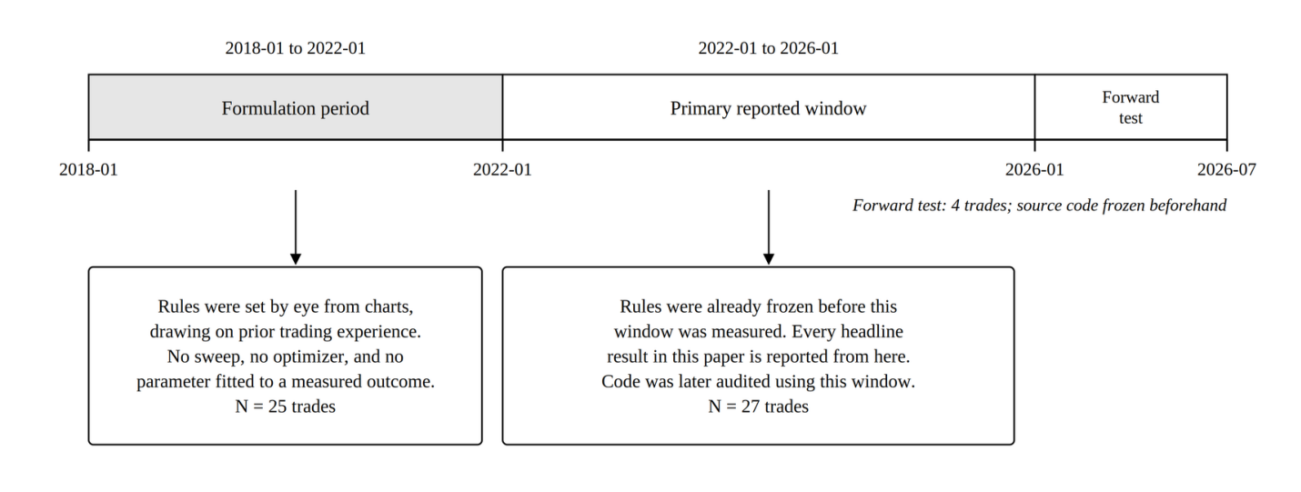

B. Materials and Sources
BTC/USDT 4-hour candlestick data (Binance, via API). Open, high, low, close, and volume were pulled from the Binance public price endpoint for BTCUSDT at 4-hour resolution, in batches of 1,000 candles. Millisecond timestamps were converted to datetimes and shifted forward eight hours, so all stored timestamps are UTC+8. Every timestamp in this paper follows that convention. Figure 2 shows the collection and verification sequence.
Figure 2
Data Collection, Timestamp Conversion, and Dataset Verification
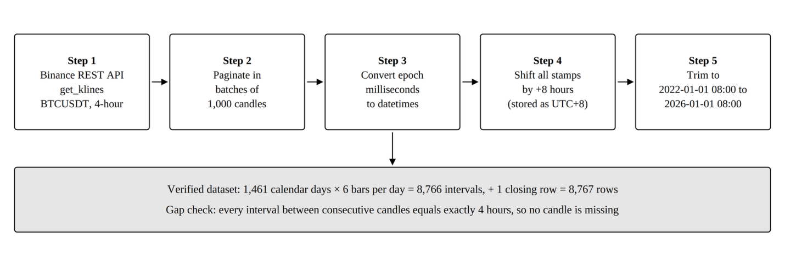
The dataset runs from 2022-01-01 08:00:00 to 2026-01-01 08:00:00, a span of exactly 1,461 days (365 + 365 + 366 + 365, the 366 covering the 2024 leap day). At six 4-hour candles a day, that is 1,461 × 6 = 8,766 intervals. The closing candle is stored as its own row, so the file holds 8,766 + 1 = 8,767 rows. A gap check found a single time difference between consecutive candles, four hours, and no duplicate timestamps. No candle is missing.
The 2018 to 2022 build window holds 8,750 rows against the 8,767 expected under the same counting. That is seventeen candles missing across eight exchange outages, the largest a seven-candle gap. It is disclosed for completeness and does not affect any figure from the primary window.
BTC/USDT 1-hour candlestick data (Binance, via API). For SOP 5 only, 1-hour candles were pulled once from the same public endpoint on 2026-10-26: 77,164 closed candles from 2018-01-01 00:00 to 2026-10-26 05:00. Unlike the 4-hour file these timestamps are kept in UTC, with no eight-hour shift. The feed has 27 gaps totalling 122 missing hours, all but one in 2018 to 2021, and they are left unfilled, the same as the 4-hour data. As a check, the 1-hour candles were combined back into 4-hour candles and compared with the 4-hour file: 18,826 of 18,828 matched exactly. One of the other two sits on a missing hour, and the other is the 4-hour file's last candle, which was still open when that file was saved.
Python 3 environment. Backtesting logic was implemented using pandas, numpy, python-binance, and gspread with oauth2client.
SciPy. A free, open-source scientific computing library for Python, widely used in published research (Virtanen et al., 2020). Every standard textbook test in this paper is an unmodified call into scipy.stats.
Google Sheets and SQL database. Simulation results were exported to Google Sheets and to a local SQL database, including per-trade records.
LuxAlgo Smart Money Concepts indicator (LuxAlgo, 2022). Order Block detection is a Python translation of the LuxAlgo indicator for TradingView, using a 50-candle swing pivot lookback and a 5-candle internal pivot lookback.
Average True Range (Wilder, 1978). True range follows Wilder's definition. Both ATR windows use a plain rolling mean, not Wilder's original exponential smoothing. That is what the code does and what this paper reports.
Web-based verification dashboard. A separately written JavaScript dashboard recomputes the indicator and entry-condition layer in the browser, as a cross-check from a second codebase. Its scope is deliberately narrow. It does not detect Order Blocks, Fair Value Gaps, or liquidity sweeps, and it imports nothing from the Python analysis. That independence is why the two bootstrap intervals in the Findings are reported separately rather than merged.

C. Variables
Independent variable. How capital is allocated over one identical stretch of price history, at six levels. Three are standalone arms: the Order-Block-gated strategy alone, weekly dollar-cost averaging into Bitcoin, and one lump-sum purchase held to the end. Three are blends that put 10%, 20%, and 30% of new weekly contributions into the strategy and dollar-cost average the rest. The 0% blend is the same arm as pure weekly averaging and appears as the blended model's baseline row.
Dependent variables. For the strategy's own trades: win rate, total net return, average return per trade, and return concentration. For the comparison against passive options: total return and final capital from a fixed start, annualized Sharpe ratio, maximum drawdown, and time in market.
Controlled variables. Trading pair, candle interval, and backtest window are the same for every arm. The MACD, KDJ, and ATR settings, the exit rules, and the minimum reward-to-risk requirement are the same wherever the strategy appears. Starting capital is $10,000 for every head-to-head arm. The schedule is 210 equal weekly contributions for the averaging arm and every blend. The cost assumption is applied at the same rate to every arm in a given comparison.
Follow-up analyses. In SOP 4 the independent variable is which entry gates are switched on, at nine settings plus the full rule. In SOP 5 it is the candle interval, at three levels: 4-hour, 1-hour with every setting unchanged (the literal version), and 1-hour with every window stretched four times (the time-scaled version). The dependent variables are trade count, trades per year, win rate, and average and total return per trade before and after a 0.20% round-trip cost. Every threshold in Table 1, every exit rule, and the Order Block detection code are held fixed.

D. Strategy Formulas
Throughout this section, C, H, L, and V with subscript t denote the closing price, high, low, and traded volume of candle t.
MACD (12, 26, 9). Momentum confirmation comes from the gap between a fast and a slow exponential moving average. Every value uses only past and present candles.
${EMA}_{12}(t) = C_{t} × \frac{2}{13} + {EMA}_{12}(t−1) × (1 − \frac{2}{13})$
${EMA}_{26}(t) = C_{t} × \frac{2}{27} + {EMA}_{26}(t−1) × (1 − \frac{2}{27})$
${MACD}_{t} = {EMA}_{12}(t) − {EMA}_{26}(t)$
${Signal}_{t} = {MACD}_{t} × \frac{2}{10} + {Signal}_{t−1} × (1 − \frac{2}{10})$
${Hist}_{t} = {MACD}_{t} − {Signal}_{t}$
ATR (14) and ATR (200). True range measures how far price travelled on a candle. ATR averages it.
${TR}_{t} = max\left(H_{t} − L_{t} , \left|H_{t} − C_{t−1}\right| , \left|L_{t} − C_{t−1}\right|\right)$
${ATR}_{14}(t) = \frac{1}{14} × \sum_{i=0}^{13}{}{TR}_{t−i}$
${ATR}_{200}(t) = \frac{1}{200} × \sum_{i=0}^{199}{}{TR}_{t−i}$
ATR₁₄ sets stop-loss distance, the minimum-stop filter, the trailing exit, and the ATR-move exit. ATR₂₀₀ is the volatility baseline for the market-condition filter and for two Order Block criteria, Displacement and Large Origin Candle.
KDJ (9, 3, 3), the fixed entry gate. Computed once over the whole dataset. It does not vary from trade to trade, and every K, D, and J reference inside the entry conditions reads this series at the current candle.
${RSV}_{t} = \left[\frac{C_{t} − min L across the last 9 candles}{max H across the last 9 candles − min L across the last 9 candles}\right] × 100$
$K_{t} = \frac{2}{3} K_{t−1} + \frac{1}{3} {RSV}_{t}$
$D_{t} = \frac{2}{3} D_{t−1} + \frac{1}{3} K_{t}$
$J_{t} = 3K_{t} − 2D_{t}$
KDJ, the adaptive exit series. A second system that exists only to time one exit signal after a trade is open. It never shares state with the fixed series above. At entry it is seeded from that series' K and D at the entry candle. Its window length is set once and held for the life of the trade:
$w = max\left(1, candles elapsed since the Order Block\right)$
On each later candle a Raw Stochastic Value is recomputed over a rolling window of length w, and K and D are updated with the same one-third smoothing:
${RSV}_{custom} = \left[\frac{C_{cur} − min L across the window}{max H across the window − min L across the window}\right] × 100$
$K_{cur} = \frac{2}{3} K_{prev} + \frac{1}{3} {RSV}_{custom}$
$D_{cur} = \frac{2}{3} D_{prev} + \frac{1}{3} K_{cur}$
Across the 27 trades, w ranged from 14 to 439 candles, with a median of 74. Only w varies between trades; the entry gate never does. These are two separate systems by design.
Order Block detection. Two independent structural passes run over the same price series, one with a 5-candle pivot lookback for internal structure and one with a 50-candle lookback for swing structure. Figure 3 sets out the detection and scoring sequence.
Figure 3
Order Block Detection, Quality Scoring, and Eligibility
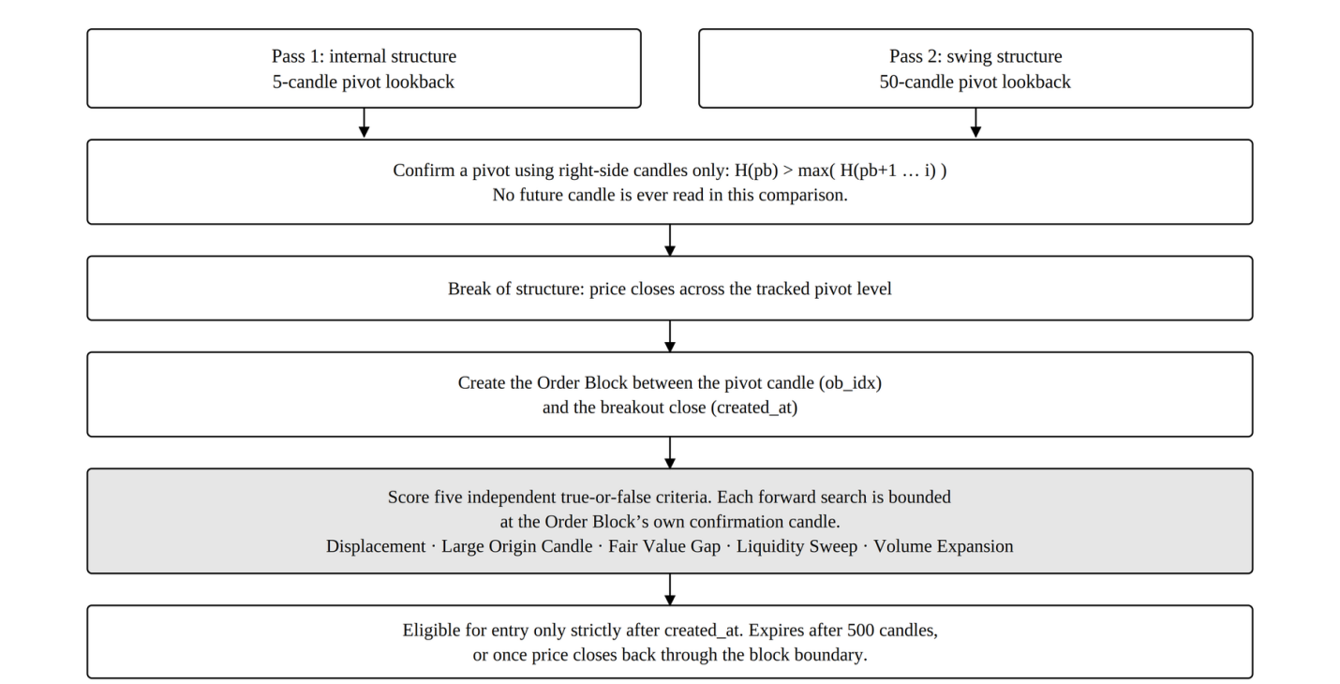
In each pass a candle becomes a pivot high only by right-side comparison: its high must exceed every high that follows it, up to the breakout candle. A pivot low is the mirror. No future candle is read. A break of structure is flagged when price closes across a tracked pivot level. An Order Block is then created from the price segment between the pivot candle and the candle whose close confirms the break. Two candles are tracked separately on purpose: the one holding the Order Block's own extreme, and the one where the breakout closes. An Order Block cannot trigger an entry until strictly after its confirmation candle. Order Blocks expire after 500 candles, or as soon as price closes back through their boundary.
Order Block quality criteria. Each Order Block is scored on five separate true-or-false criteria. Their sum, 0 to 5, is used only as an entry-eligibility threshold. The baseline reported here uses a threshold of 0, so no Order Block is excluded by score.
1. Displacement: within the candles immediately following the Order Block's own candle, and bounded at that Order Block's own confirmation candle, a candle body move of at least 1.5 times ATR₂₀₀ occurs in the Order Block's direction.
2. Large Origin Candle: the high minus the low of the Order Block's candle is at least ATR₂₀₀ at that candle, meaning the block's own candle is at least as tall as the long-run average candle.
3. Fair Value Gap: a three-candle price imbalance exists within a bounded window following the Order Block's candle. For a demand block the low of the third candle exceeds the high of the first; for a supply block the mirror condition holds.
4. Liquidity Sweep: the low of the Order Block's candle is at or below the minimum low over the prior ten candles for a demand block, or its high is at or above the maximum high over the prior ten candles for a supply block.
5. Volume Expansion: the volume of the Order Block's candle is at least 1.25 times the mean volume over the prior twenty candles, or the candle body exceeds 60% of the candle's own high-to-low range.
Both the Displacement and the Fair Value Gap search windows are bounded at the Order Block's own confirmation candle.
Fixed parameters. Every value below was set before, and independently of, the analysis reported here.
Table 1
Fixed Strategy Parameters
Parameter | Value
Minimum stop distance | 0.015, meaning 1.5% of entry price
KDJ J cap, long entries | 60.0
KDJ K cap, long entries | 50.0
KDJ K floor, short entries | 70.0
KDJ J cap, short entries | 100.0
ATR-move take-profit multiple | 1.8
Breakeven-stop trigger multiple | 2.0
Minimum reward-to-risk ratio | 1.5
Order Block expiry | 500 candles
Internal pivot lookback | 5 candles
Swing pivot lookback | 50 candles
Note. Every value was set during the 2018 to 2022 formulation period and was never adjusted afterwards.
Entry conditions. A long entry needs all six conditions in Figure 4 to hold at the same candle close. A short entry is the mirror against a supply Order Block, with K above 70 and J at or below 100.
Figure 4
Long Entry Decision Sequence
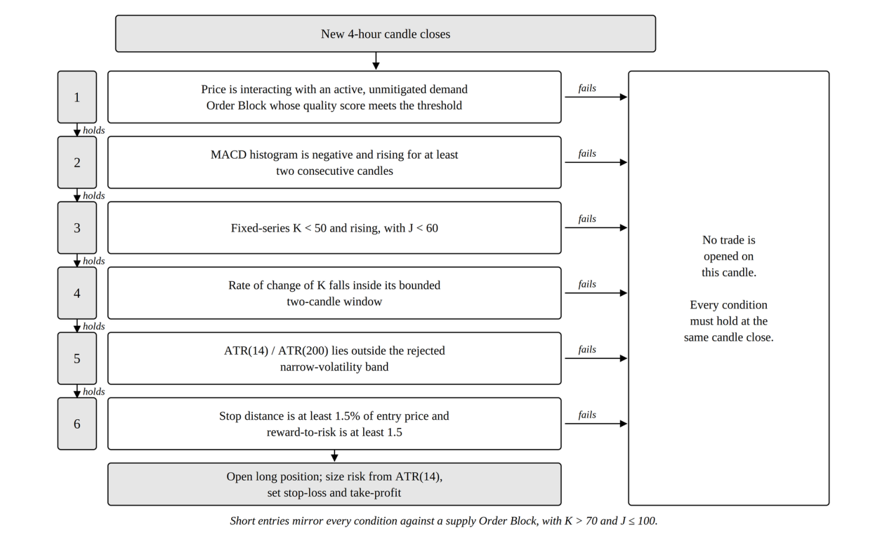
Exit conditions. Exits are checked on every candle in the fixed order shown in Figure 5. The first condition met triggers the exit and the rest are not checked for that candle.
Figure 5
Exit Priority Order
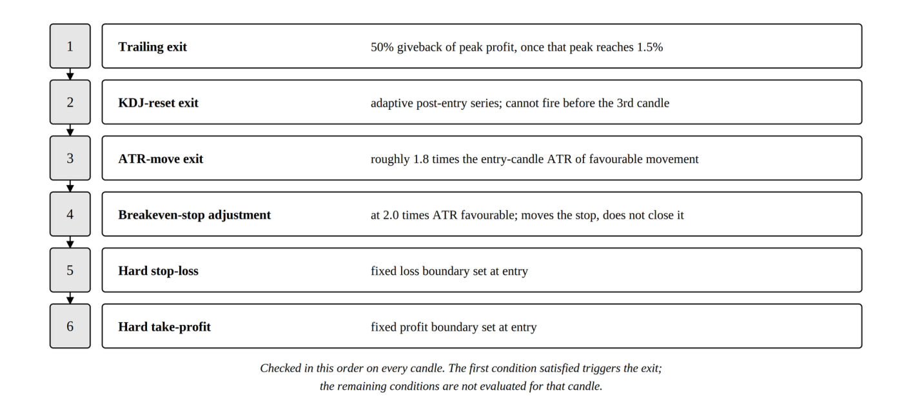
Time-scaled 1-hour version (SOP 5 only). An hour is a quarter of a 4-hour candle. In the time-scaled version every window counted in candles is multiplied by four, so it spans the same clock time as on 4-hour candles: MACD (48, 104, 36), a KDJ window of 36, ATR windows of 56 and 800, pivot lookbacks of 20 and 200, and an Order Block expiry of 2,000 candles. Pattern shapes and price thresholds are not windows and stay as in Table 1: the two-candle MACD rise, the three-candle K-acceleration and its range, the stop-loss and reward-to-risk minimums, the exit multiples, and the Order Block quality windows. The literal version changes nothing, so each of its windows covers a quarter of the clock time it covers on 4-hour candles.

E. Portfolio Construction and Contribution Schedule
This section gives the full construction of every comparison arm, so a reader can rebuild Tables 9 through 12 by hand.
Shared timing rule. A contribution lands on the first bar of every ISO calendar week and buys at that bar's close. The blended model and the head-to-head averaging arm both use this rule, so the two cannot drift apart. The primary window holds 210 such weeks. The 2018 to 2022 window holds 209.
Head-to-head arms. Each starts from $10,000. The strategy arm holds the full amount in cash from the first bar and compounds only at each trade exit bar, by that trade's percentage return. Each trade commits the full amount; positions are unlevered and never partly sized. Between trades the arm sits in cash and earns nothing. Returns are measured per 4-hour bar and annualized with m = 6 × 365.25 = 2,191.5.
The weekly averaging arm contributes $10,000 ÷ 210 = $47.6190 per week, or $10,000 ÷ 209 = $47.8469 in the 2018 window. Each contribution buys at that bar's close. Value at any bar is units held times the current close. Period returns are measured only at contribution bars and are net of that week's own contribution, so new money is never counted as return:
$r_{k} = \left(V_{k} − C_{k}\right) / V_{k−1} − 1$
That arm is annualized with m = 52. The lump-sum arm buys the full $10,000 at the first bar's opening price, not the close the averaging arm uses, and holds to the last bar's close. Lump-sum returns are per 4-hour bar, annualized with m = 2,191.5.
One reconciliation applies wherever the strategy arm appears. Its Total return column is the arithmetic sum of the individual trade returns, the convention behind the +30.31% headline throughout this paper. Its Final capital column instead compounds those same returns in sequence from the $10,000 start. Compounded, the strategy returns +34.18% over the primary window, which is what produces $13,417.77. The two passive arms hold one position throughout, so no such gap arises for them.
In the net-of-cost version in Table 10, the strategy arm pays a 0.20% round-trip drag taken off each trade's return. The two passive arms pay a 0.10% one-sided markup on the buy price, since they buy and hold instead of round-tripping.
Blended-sleeve model. Contributions here are 1.0 relative unit per week across 210 weeks, not dollars. Table 12 therefore has no dollar column and should not be read against the $10,000 used elsewhere. In the 100% / 0% baseline the full unit buys Bitcoin at that bar's close. At a strategy share f of 0.10, 0.20, or 0.30, the remaining share buys Bitcoin and f goes into a strategy sleeve held as cash. The sleeve compounds by each trade's return at that trade's exit bar and is never moved back into Bitcoin. Portfolio value at any bar is Bitcoin units times the close, plus the sleeve's cash. Period returns are measured at the 210 contribution bars, net of that week's contribution, and annualized with m = 52. Maximum drawdown in Table 12 includes principal and is computed on the portfolio value series at contribution bars.
Table 12's 100% / 0% row and Table 9's Weekly DCA row give the same Sharpe of 0.556 and the same maximum drawdown of −27.85%, because both use the same weekly rule. The two tables meeting at their shared point is a free consistency check.

F. Data Analysis
The main approach is exploratory data analysis (Tukey, 1977): descriptive statistics, distribution summaries, and table comparison, used to find patterns before drawing conclusions. It suits this case because the backtest output is a finite, fully observed set of trade records with no missing values. The descriptive statistics reported are trade count, win rate, net return, average return, and standard deviation.
Statistical Software and the Division Between Library and Custom Code
All statistics were computed in Python 3 using SciPy, a free open-source library whose routines are used across published quantitative research (Virtanen et al., 2020). The standard tests here are therefore library code, not this study's own, which removes a whole class of possible arithmetic error.
This paper reports exactly nine quantities. Three are unmodified SciPy calls. Six are formulas written for this study, either because no single library function computes them or because they follow this study's own resampling design. Sharpe and maximum drawdown are descriptive measures, not hypothesis tests, and no p-value is attached to either anywhere in this paper.
Table 2
Division Between SciPy Library Calls and Formulas Written for This Study
Quantity | Source | Routine
Exact binomial test on win rate | SciPy | scipy.stats.binomtest
Pearson’s correlation and its p-value | SciPy | scipy.stats.pearsonr
Spearman’s correlation and its p-value | SciPy | scipy.stats.spearmanr
Bootstrap confidence interval on total return | Custom | Percentile bootstrap, Formula 1
Maximum drawdown | Custom | Running-peak decline, Formula 2
Sharpe ratio | Custom | Annualized risk-adjusted return, Formula 3
Stationary block bootstrap p-value and interval on average return (SOP 5) | Custom | Formula 4
Bootstrap difference in average return between two trade sets (SOP 4) | Custom | Formula 5
Holm adjustment for nine simultaneous tests (SOP 4) | Custom | Formula 6
Note. Formula numbering runs 1 to 6. Appendix B gives each custom formula in source form.
Tests Computed by SciPy
One-sided exact binomial test. With n closed trades and w winners, and a null win probability of 0.5, the one-sided p-value is the sum, for k from w to n, of n-choose-k times 0.5 to the power n:
$p_{one−sided} = \sum_{k=w}^{n}{}C(n, k) {(0.5)}^{k} {(0.5)}^{n−k} = \sum_{k=w}^{n}{}C(n, k) {(0.5)}^{n}$
A p-value is the chance of a result at least this strong if the strategy had no edge at all. The one-sided form was chosen because the hypothesis is directional. Two-sided values are given for reference.
Correlation. Pearson's r and Spearman's ρ were computed between how long a trade was held, in candles, and its percentage return. Pearson assumes a straight-line relationship; Spearman assumes only a consistent direction.
Formulas Written for This Study
Formula 1. Percentile bootstrap confidence interval. Let r₁, r₂, …, r_n be the percentage returns of the n trades. For each of B repetitions, draw n returns from that set at random with replacement and record the resample's total and mean:
$T^{(b)} = \sum_{i=1}^{n}{}{r_{i}}^{(b)}$
${\bar{T}}^{(b)} = \frac{1}{n} × \sum_{i=1}^{n}{}{r_{i}}^{(b)}, b = 1, 2, …, B$
The 95% confidence interval is the 2.5th and 97.5th percentiles of the B recorded values:
${CI}_{95\%} = \left[Q_{2.5}\left(T^{(1)}, …, T^{(B)}\right) , Q_{97.5}\left(T^{(1)}, …, T^{(B)}\right)\right]$
Twenty-seven trades is too few, and too skewed by a few large winners, for a normal-theory interval to be safe. The bootstrap assumes nothing about the shape of the distribution; it uses the data's own shape instead (Efron & Tibshirani, 1993). Drawing exactly n values with replacement follows Efron, so the spread between resamples reflects sampling uncertainty rather than a changed sample size. The parameters are B = 10,000, n = 27, and a fixed seed of 42, so the figure is exactly reproducible. This is the plain percentile bootstrap, not the bias-corrected and accelerated version. That is a choice, not the only option.
Formula 2. Maximum drawdown. Let E_t be the value of an equity curve at time t. Define the running peak, the percentage decline from that peak, and the worst such decline:
$P_{t} = \max_{u ≤ t} E_{u}$
${DD}_{t} = \left[\frac{E_{t} − P_{t}}{P_{t}}\right] × 100$
$MDD = \min_{t} {DD}_{t}$
Drawdown is a percentage, not dollars, so the three arms can be compared directly despite very different equity-curve shapes. Tracking the running peak, rather than comparing only the final value to the all-time high, catches a fall partway through that later recovers.
Formula 3. Sharpe ratio. Let R₁, R₂, …, R_N be an arm's per-period returns, R̄ their mean, s_R their standard deviation, and m the number of periods in a year for that arm's own reporting frequency:
$SR = \left(\frac{\bar{R}}{s_{R}}\right) × \sqrt{m}$
The Sharpe ratio measures the return an arm earned per unit of the variability it went through, so a higher value means a smoother ride for the same return (Sharpe, 1994). It is computed here with the risk-free rate set to zero, using raw per-period returns rather than returns in excess of a benchmark rate.
Formula 4. Stationary block bootstrap. Trades that follow each other can share the same market mood, so drawing them one at a time, as Formula 1 does, can understate the uncertainty. The stationary bootstrap (Politis & Romano, 1994) instead copies runs of consecutive trades. Starting from a random trade, each next draw continues the current run with probability 1 − 1/L or jumps to a new random trade with probability 1/L, wrapping from the last trade back to the first, until n returns are drawn. L, the expected run length, is n^(1/3) rounded, which gives L = 3 for 31 trades. With B = 10,000 resamples and seed 20260808, the one-sided p-value is the share of resample means at or below zero, and the 95% interval is the 2.5th and 97.5th percentiles of those means. It is used only for H₀₄, as pre-registered.
Formula 5. Bootstrap difference in average return. Each gate setting trades a different set of trades from the full rule, so the two sets cannot be paired. For each of B = 2,000 repetitions, one resample is drawn with replacement from each set at its own size, and the difference between the two resample means is recorded. The 95% interval is the 2.5th and 97.5th percentiles of those differences. The two-sided p-value is twice the smaller of the shares of differences at or below zero and at or above zero, capped at 1.
Formula 6. Holm adjustment. Sort the m = 9 raw p-values from smallest to largest, p₍₁₎ ≤ … ≤ p₍ₘ₎. The adjusted value for the i-th is the largest of (m − j + 1) × p₍ⱼ₎ over every j up to i, capped at 1. The smallest p-value is multiplied by 9, the next by 8, and so on, and an adjusted value is never allowed to fall below the one before it (Holm, 1979). A result counts as significant only if its adjusted value is below 0.05.
Additional analyses. The headline result was recomputed under six cost scenarios. It was compared against the two passive alternatives both gross and net of fees, and re-run on data that came after the code was finished. The binomial test is re-run in full on each fee-adjusted trade set rather than adjusted from the gross p-value. Both follow-up analyses use a single-trade simulator that runs the same exit rules from any entry candle; with all four gates on it reproduces all 27 baseline trades exactly, and on 1-hour data it reproduces every trade the main engine makes.
Reproducibility. A golden-master regression harness recomputes the indicators and the full simulation from raw candle data. It requires exact agreement with committed reference files: indicators to a tolerance of 10⁻⁶, and all 27 trade records exactly. It runs after every code change. Truncation-equality testing on the ATR(14), ATR(200), and fixed KDJ(9,3,3) series passed 180 of 180 sampled checks. Each indicator recomputed on a shortened dataset gave exactly the same values, which is what must happen if no future data is used. The separate JavaScript dashboard gives a second cross-check on the indicator and entry-condition layer. All results appear as observed, including non-significant and unfavourable ones.

Findings
This section is organized around the three research questions. Each subsection opens with a direct answer, then gives the evidence behind it. Interpretation is held back to the Conclusions. Appendix A traces every number here to the function that produced it, and Appendix D shows how to recompute by hand each number that can be recomputed by hand.

Answers to SOP 1 and Hypotheses H₀₁ and H₁₁
Note. Refer to page for the question being answered.
Answer: yes before costs, no after them. The strategy won 70.37% of 27 trades for +30.31% total net return at p = 0.0261, and the bootstrap interval on total return excludes zero. Charging a realistic 0.20% round trip moves p to 0.1239, so H₀₁ is not rejected once costs a real trader would pay are charged.
Table 3
Baseline Strategy Performance, 2022 to 2026 Window, Gross of Costs
Metric | Value
Trades | 27
Wins / Losses | 19 / 8
Win rate | 70.37%
Total net return | +30.31%
Average return per trade | +1.1225%
Standard deviation of return per trade | 2.41%
One-sided binomial p | 0.0261
Two-sided binomial p | 0.0522
Note. Exact binomial test on 27 trades with 19 wins against a null win probability of 0.5.
With 27 trades and 19 wins, the one-sided exact binomial test gives
$P\left(K ≥ 19 ; n = 27, p = 0.5\right) = \sum_{k=19}^{27}{}C(27, k) {(0.5)}^{27} = 0.0261$
If the strategy had no edge, a run this good would happen about 26 times in every 1,000 attempts. Each trade is named throughout this paper by the candle index where it was entered: 335, 359, 673, 902, 1050, 1158, 1913, 2624, 2859, 3100, 3196, 3859, 3947, 4455, 5800, 5825, 6040, 6109, 6366, 6537, 6991, 7109, 7938, 7964, 8188, 8280, and 8596. The full per-trade record is Appendix C.
Bootstrap interval. A bootstrap of 10,000 resamples, drawn at the original sample size of 27 with a fixed seed of 42, gives a point estimate of +30.3065% total net return, which differs from the observed sum of +30.3064% only in the fourth decimal. The 95% confidence interval is [+5.9866%, +54.9866%]. It is wide but excludes zero, and 99.25% of resampled totals were positive. The matching interval for average return per trade is [+0.2217%, +2.0365%]. The companion website recomputes the same bootstrap in the browser at 2,000 resamples and lands on [+7.48%, +54.46%]. That is separate TypeScript code with its own random number generator, and the gap between the two intervals was traced to the resample count alone. They are kept separate rather than merged, because the website's independence is what makes the cross-check worth anything.
Cost sensitivity. Six scenarios were run: gross, fee-only, and four spanning 0.14% to 0.40% round trip. The confirmed Binance USDT-M Futures standard taker rate is 0.05% per side, giving 0.10% for a round trip, and slippage was modelled separately at a conservative 0.05% per side.
Table 4
Win Rate and Significance Across Six Transaction-Cost Scenarios
Round-trip cost | Wins (of 27) | Win rate | Total net return | p (one-sided) | Significant at .05?
0.00% (none) | 19 | 70.37% | +30.31% | 0.0261 | Yes
0.10% (fee only) | 19 | 70.37% | +27.61% | 0.0261 | Yes
0.14% | 17 | 62.96% | +26.53% | 0.1239 | No
0.20% (primary) | 17 | 62.96% | +24.91% | 0.1239 | No
0.24% | 17 | 62.96% | +23.83% | 0.1239 | No
0.40% | 15 | 55.56% | +19.51% | 0.3506 | No
Note. Round-trip cost is the total fee and slippage paid on one trade, entry plus exit, and is subtracted from each of the 27 trade returns. A trade counts as a win only if its return after that cost is above zero. Costs therefore turn small winners into losers, which is why the win rate falls as cost rises: trades 7938 and 8188 become losses from 0.14% upward, and trades 2859 and 5825 also become losses at 0.40%. Each row re-runs the one-sided binomial test against a 50% win rate.
Figure 6
Win Rate and Significance Across Six Transaction-Cost Scenarios
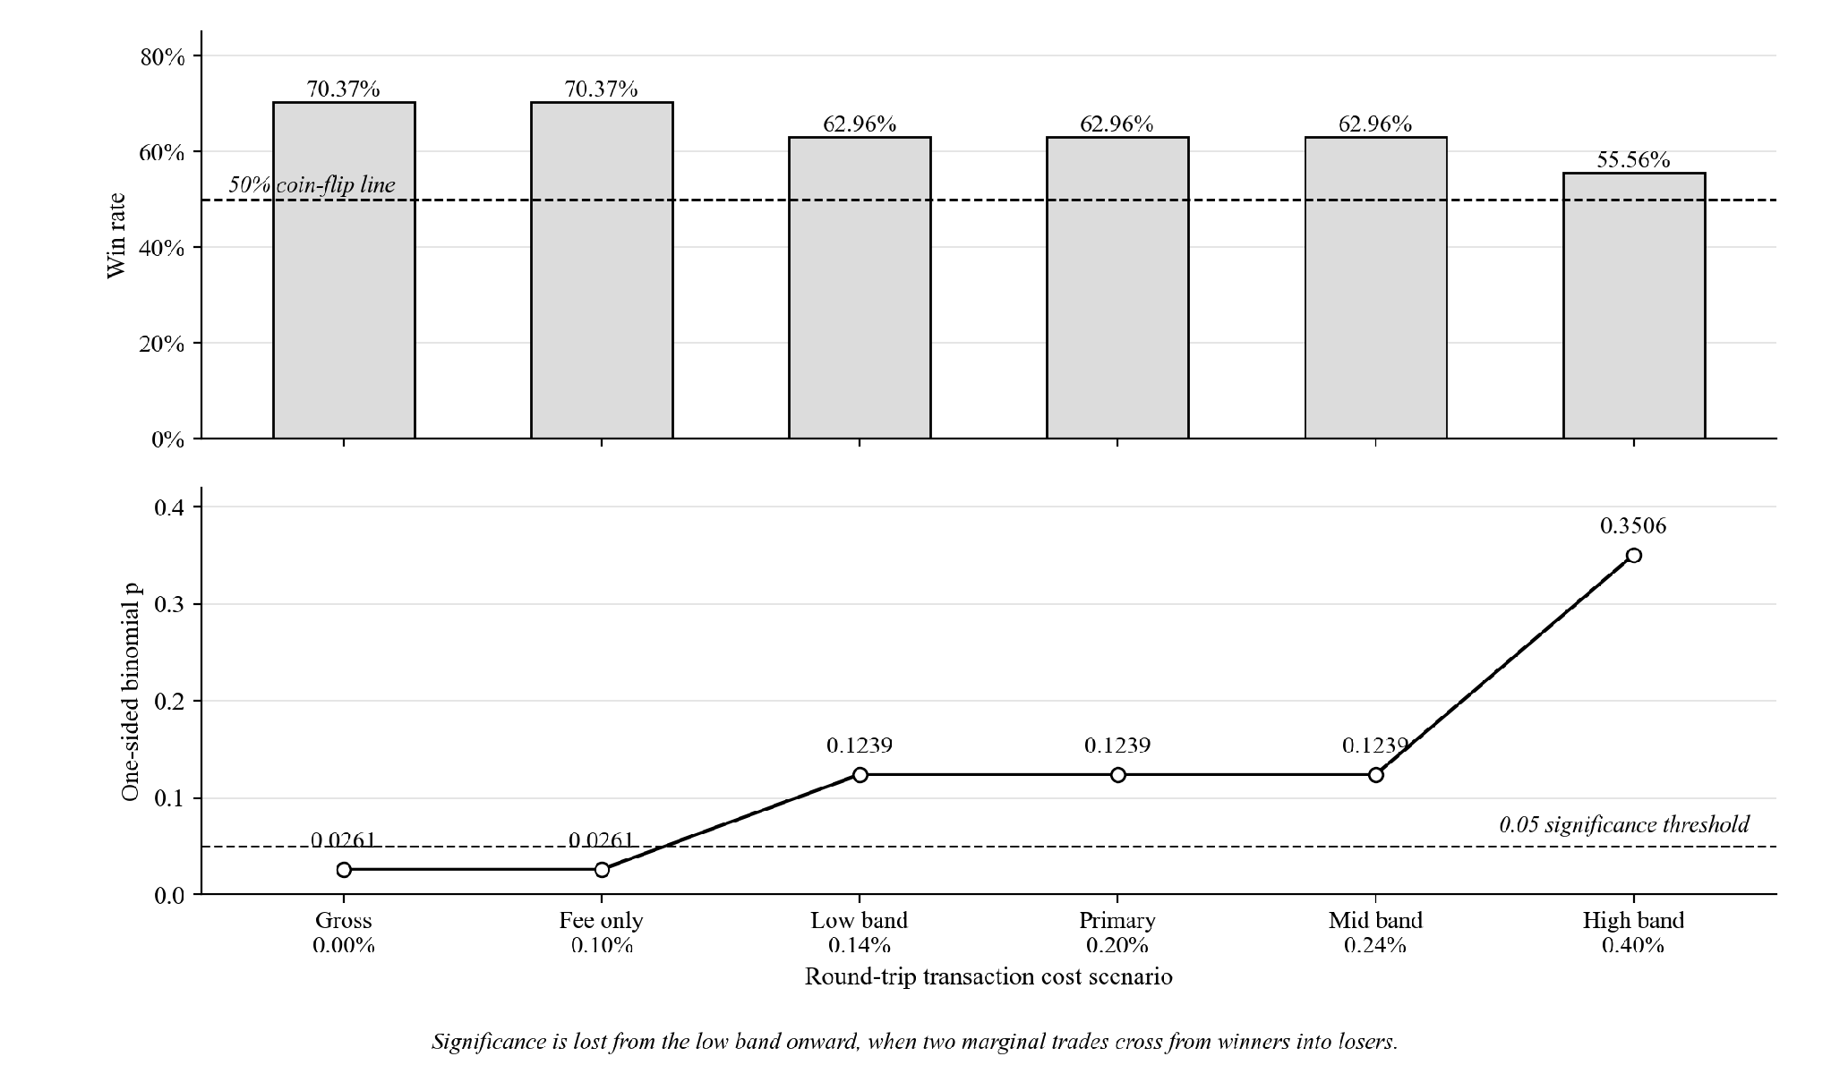
The flip comes from exactly two trades, those at candle indices 7938 and 8188, worth +0.12% and +0.13% before costs, crossing from winners into losers.
Regime dependence. Trades were tagged by market condition at entry using two independent methods. The first is a calendar split. The second measures how far price sat below its previous all-time high, starting from Bitcoin's pre-window high of $69,000 on 2021-11-10, with bear at 40% or more below that high, sideways between 40% and 12% below, and bull less than 12% below.
Table 5
Performance by Calendar Regime
Regime | Trades | Win rate | Return contribution | Share of total return
Bear (2022) | 7 | 57.14% | +10.45% | +34.5%
Chop (2023) | 6 | 50.00% | −5.39% | −17.8%
Bull (2024 to 2025) | 14 | 85.71% | +25.25% | +83.3%
Note. The three rows partition the same 27 trades, so counts sum to 27 and contributions sum to +30.31%.
Table 6
Performance by Drawdown-From-High Regime
Regime | Trades | Win rate | Return contribution | Share of total return
Bear (at or below −40% from high) | 12 | 50.00% | −1.63% | −5.4%
Chop (−40% to −12% from high) | 8 | 87.50% | +18.89% | +62.3%
Bull (above −12% from high) | 7 | 85.71% | +13.05% | +43.1%
Note. The same 27 trades, re-partitioned by a different definition of market regime.
The two methods agree on only 13 of the 27 assignments, because they measure different things. Much of 2023 sat 57% to 64% below the all-time high even though price that year was range-bound rather than falling. Both methods agree that bull is the strongest regime, at an 85.71% win rate under each.
Holding time and return. Across the same 27 trades, Pearson's r = +0.4907 with t = 2.82, df = 25, and p ≈ 0.0094. Spearman's ρ = +0.4797 with p ≈ 0.0113. Trades held longer tended to end up larger, and the pattern holds at both the 5% and 1% thresholds.
Forward test. A forward out-of-sample test used 4-hour data from 2026-01-01 to 2026-07-31, a period that came after every change to the code, run through the identical frozen pipeline after first confirming the locked 27-trade baseline reproduced exactly.
Table 7
Forward Out-of-Sample Result, January to July 2026
Metric | Value
New out-of-sample trades | 4
Wins / Losses | 1 / 3
Win rate | 25.00%
Total return | −3.45%
Average return per trade | −0.86%
Note. Same frozen pipeline as Table 3, applied to candles after 2026-01-01 08:00:00.
This is reported as it came out: small and unfavourable. A separate eight-year backfill check ran the same pipeline on data extended back to 2018-01-01, to test whether four extra years of indicator warm-up would change the locked results. All 27 locked trades matched by entry timestamp, with a maximum profit-and-loss difference of 0.0000000000%.
Table 8
Comparison of the Formulation Window, the Primary Window, and Their Combination
Window | N | Win rate | Total return | Avg return/trade | Binomial p (1-sided)
2018-01 to 2022-01, formulation period, not out-of-sample | 25 | 60.00% | +21.82% | +0.87% | 0.2122
2022-01 to 2026-01, primary reported window | 27 | 70.37% | +30.31% | +1.12% | 0.0261
Combined 2018 to 2026, mixed provenance | 56 | 62.50% | +48.68% | n/a | 0.0407
Note. Each row is a separate binomial test. The combined row is the 25 formulation trades, the 27 primary trades, and the 4 forward-test trades: 25 + 27 + 4 = 56, and 15 + 19 + 1 = 35 wins.
The combined row should never be cited on its own, because about half of it comes from the period the rules were built on. The strategy does worse on its own build data, at 60.00% and p = 0.2122, than on the primary window.

Answers to SOP 2
Note. Refer to page for the question being answered.
Answer: weekly buying won on final value by a wide margin, and the strategy won on risk-adjusted shape while holding a position only 2.63% of the time. Both are true and neither settles the comparison alone.
Table 9
Three-Arm Head-to-Head Comparison, 2022 to 2026, Gross of Costs
Arm | Total return | Final capital from $10,000 | Sharpe | Max drawdown | Time in market
Combined strategy | +30.31%ª | $13,417.77 | 1.1142 | −6.46% | 2.63%
Weekly DCA into BTC | +123.13% | $22,312.94 | 0.5559 | −27.85% | 100.00%
Lump-sum buy-and-hold | +90.07% | $19,007.32 | 0.5642 | −67.21% | 100.00%
Note. Time in market for the strategy is 2.6349% of candles. The summed-versus-compounded reconciliation for the strategy arm is set out in Section E. The combined strategy is the MACD, KDJ, ATR, and Smart Money Concepts strategy tested in this study. ªSimple sum of the 27 trade returns, the headline figure used throughout this paper. Compounding the same returns in sequence gives +34.18%, which produces the $13,417.77 final capital.
Figure 7
Three Arms Grown From an Equal $10,000 Start, 2022 to 2026
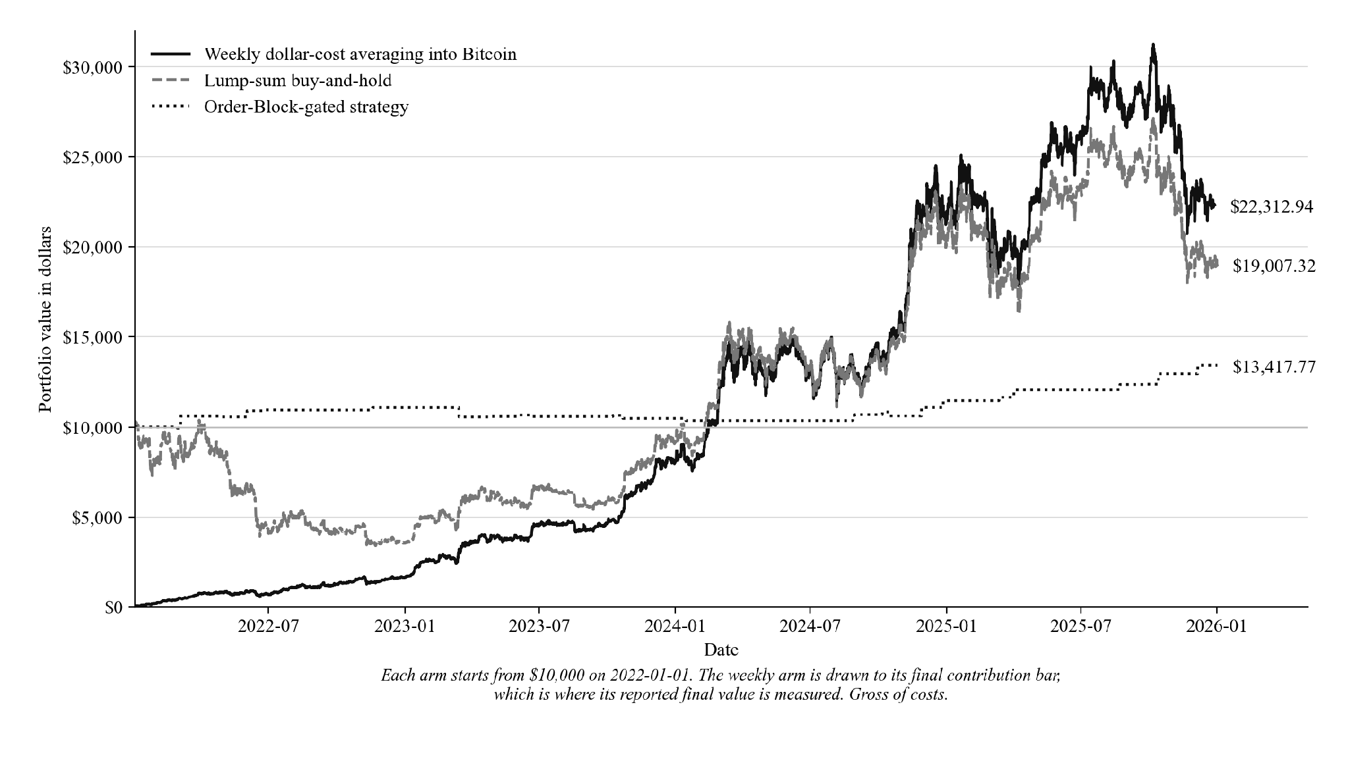
Table 10
Three-Arm Head-to-Head Comparison, 2022 to 2026, Net of Costs
Arm | Total return | Final capital from $10,000 | Sharpe | Max drawdown | Time in market
Combined strategy | +24.91%ª | $12,719.01 | 0.9442 | −7.78% | 2.63%
Weekly DCA into BTC | +122.91% | $22,290.65 | 0.5529 | −27.85% | 100.00%
Lump-sum buy-and-hold | +89.88% | $18,988.34 | 0.5642 | −67.21% | 100.00%
Note. Same construction and window as Table 9, with costs applied as set out in Section E. Both passive arms are almost unaffected, because a single purchase markup is charged once rather than 27 times. ªSimple sum of the 27 net trade returns. Compounding them in sequence gives +27.19%, which produces the $12,719.01 final capital.
Weekly buying beat the strategy on final value, $22,312.94 against $13,417.77 gross and $22,290.65 against $12,719.01 after costs. The strategy's gross Sharpe of 1.1142 exceeds buy-and-hold Bitcoin's 0.5642 over the same window, but it holds a position only 2.63% of the time against 100% for both passive arms, so this is not a like-for-like comparison.
Table 11
Three-Arm Head-to-Head Comparison, 2018 to 2022 Formulation Window, Gross of Costs
Arm | Total return | Final capital from $10,000 | Sharpe | Max drawdown | Time in market
Combined strategy | +21.82%ª | $12,282.53 | 0.681 | −6.00% | 1.87%
Weekly DCA into BTC | +439.88% | $53,987.55 | 0.824 | −46.16% | 100.00%
Lump-sum buy-and-hold | +236.96% | $33,696.49 | 0.789 | −81.42% | 100.00%
Note. Same construction as Table 9, applied to 2018-01-01 to 2022-01-01, where the weekly schedule holds 209 contributions of $47.8469. ªSimple sum of the 25 trade returns. Compounding them in sequence gives +22.83%, which produces the $12,282.53 final capital.
That window is where the rules were built, so it is shown for comparison only. Bitcoin's 2018 to 2022 window held a much bigger fall-and-recovery cycle than 2022 to 2026, which mechanically favours weekly buying by lowering its average purchase price.

Answers to SOP 3 and Hypotheses H₀₂ and H₁₂
Note. Refer to page for the question being answered.
Answer: yes. Both risk-adjusted measures improve at every step as the strategy share rises from 0% to 30%, with no reversal, which is the pattern that rejects H₀₂ in favour of H₁₂ under the descriptive standard set with the hypothesis.
Table 12
Risk-Adjusted Profile of a Blended DCA Portfolio at Increasing Strategy Allocations
Split (BTC-DCA / Strategy) | Sharpe (annualized) | Max drawdown
100% / 0% | 0.556 | −27.85%
90% / 10% | 0.581 | −26.51%
80% / 20% | 0.607 | −24.97%
70% / 30% | 0.637 | −23.18%
Note. Computed on the blended equity curve of 210 weekly contributions over 2022 to 2026, under the construction in Section E. The Sharpe ratio assumes a risk-free rate of zero.
Figure 8
Risk-Adjusted Profile Across Increasing Strategy Allocations
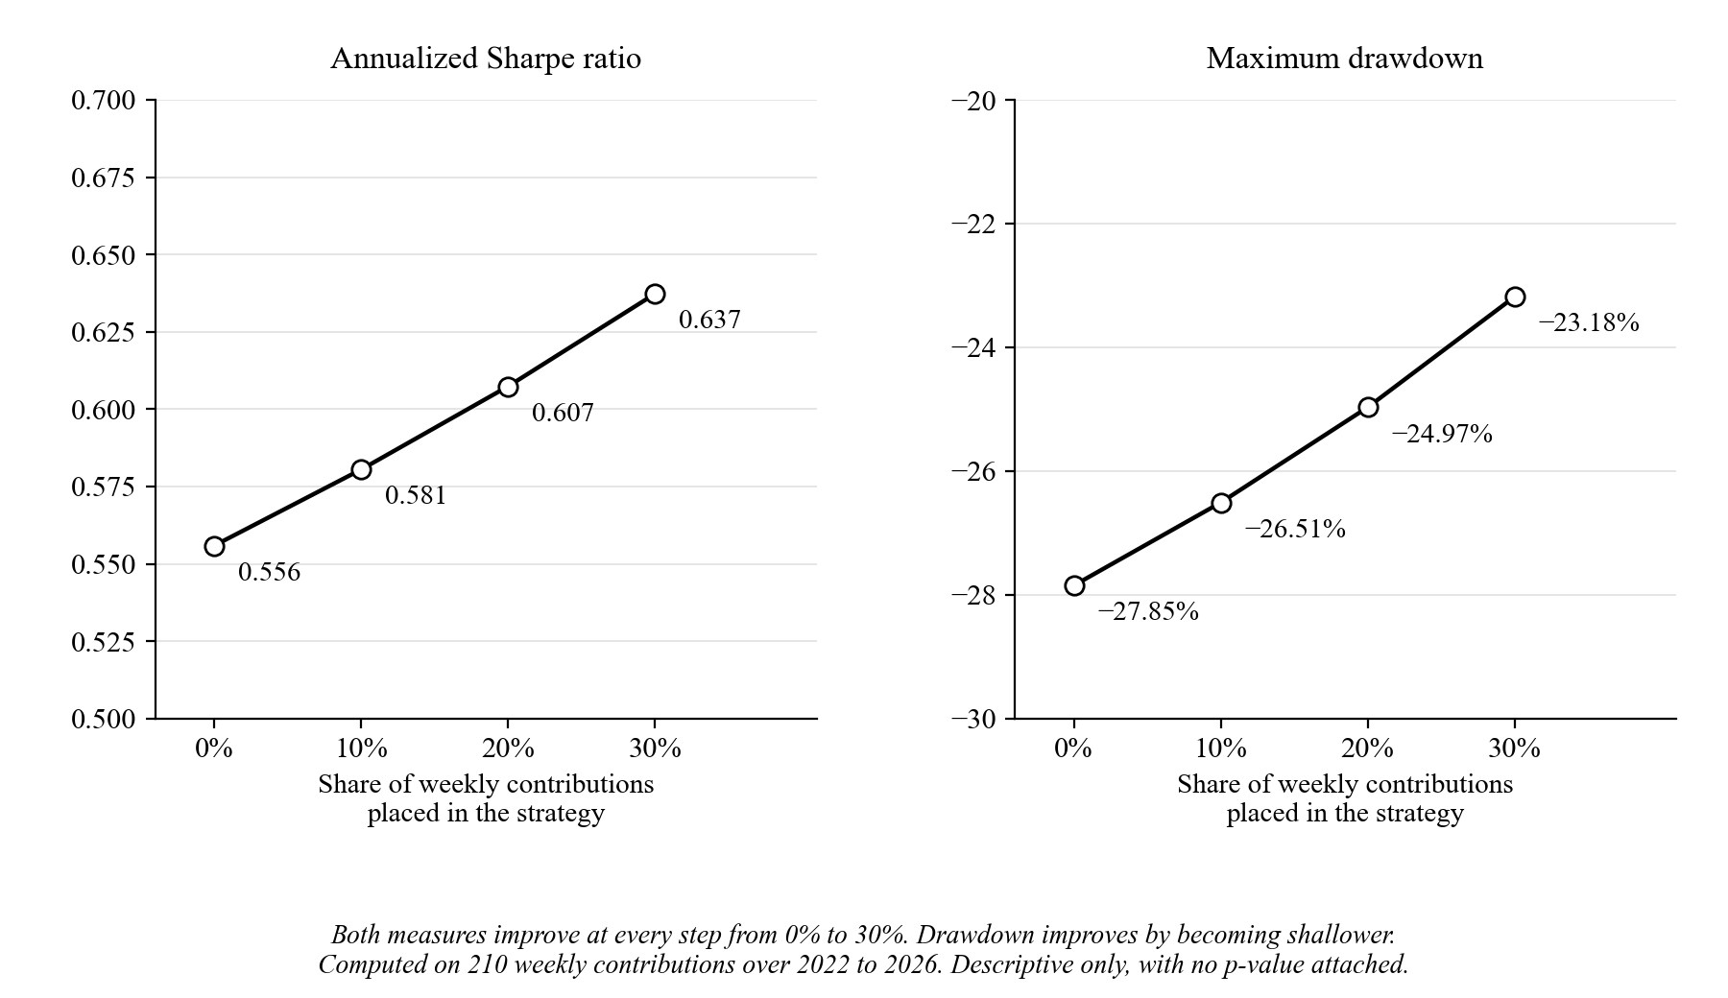
Sharpe rises from 0.556 to 0.637, and maximum drawdown shallows from −27.85% to −23.18%. The conclusion is bounded as stated with the hypothesis: it rests on one realized price path, it carries no p-value, and it shows what a blend would have done over this window, not what it will do over another.

Answers to SOP 4 and Hypotheses H₀₃ and H₁₃
Note. Refer to page for the question being answered.
Answer: every gate pulls in the same direction, but none can be shown to matter on its own. Switching off any one gate lowered average return per trade in both windows, by 0.31 to 0.89 percentage points in 2022 to 2026. No difference survived the Holm correction, so H₀₃ is not rejected.
The entry rule has four indicator gates on top of the Order Block touch: the MACD histogram gate, the KDJ gate, the K-acceleration gate, and the ATR-regime gate (Figure 4). The Order Block touch, the minimum stop distance, and the minimum reward-to-risk check stay on in every setting. Only gates are switched off, and no threshold is changed. Four settings remove one gate each, four keep one gate only, and a ninth adds an Order Block quality filter of at least 1 to the full rule. That ninth setting is not an indicator, but it was part of the same pre-registered family of nine, so it stays in the Holm correction. With all four gates on, the comparison code reproduces the 27 baseline trades exactly.
Table 13
Effect of Each Indicator Gate, 2022 to 2026 Window, Gross Average per Trade
Gate setting | Trades | Win rate | Avg return per trade | Total return net of 0.20% | Change in avg vs baseline [95% CI] | p (two-sided) | p (Holm)
All four gates (baseline) | 27 | 70.37% | +1.122% | +24.91% | — | — | —
Remove MACD | 73 | 58.90% | +0.236% | +2.65% | −0.886 [−1.97, +0.16] | 0.104 | 0.540
Remove KDJ | 53 | 56.60% | +0.411% | +11.18% | −0.712 [−1.80, +0.31] | 0.166 | 0.664
Remove K-acceleration | 46 | 60.87% | +0.601% | +18.42% | −0.522 [−1.77, +0.71] | 0.427 | 1.000
Remove ATR regime | 35 | 68.57% | +0.813% | +21.45% | −0.310 [−1.49, +0.84] | 0.582 | 1.000
MACD only | 114 | 49.12% | −0.038% | −27.13% | −1.160 [−2.15, −0.10] | 0.032 | 0.224
KDJ only | 170 | 50.59% | −0.099% | −50.75% | −1.221 [−2.27, −0.24] | 0.015 | 0.135
K-acceleration only | 224 | 56.70% | +0.340% | +31.38% | −0.782 [−1.75, +0.13] | 0.090 | 0.540
ATR regime only | 337 | 50.74% | +0.078% | −41.13% | −1.044 [−1.96, −0.13] | 0.023 | 0.184
All four + OB quality ≥ 1 | 25 | 68.00% | +1.132% | +23.31% | +0.010 [−1.31, +1.39] | 0.975 | 1.000
Note. Average return per trade is gross of costs; total return subtracts 0.20% from every trade. The change column is each setting's average minus the baseline's +1.122%, with a 95% interval from Formula 5 (B = 2,000). p (Holm) adjusts the nine p-values together using Formula 6. Each setting trades a different set of trades, one position at a time.
Removing MACD costs the most per trade, 0.886 points, and removing the ATR-regime gate the least, 0.310 points. Keeping one gate only costs between 0.782 and 1.221 points. Three single-gate settings have intervals that exclude zero, MACD only, KDJ only, and ATR regime only, with raw p-values of 0.032, 0.015, and 0.023. After the Holm correction those become 0.224, 0.135, and 0.184, so none of them can be separated from chance once nine tests are counted. Adding the Order Block quality filter changes almost nothing, +0.010 points on 25 trades.
Two settings stand out descriptively and are reported as they came. K-acceleration alone took 224 trades and returned +31.38% net of costs, more than the full rule's +24.91%, but it earned +0.140% per trade after costs against +0.922%, and its maximum drawdown was −45.60% against −7.78%. On the 2018 to 2022 window the same setting lost −118.23% net over 250 trades, so the result reversed between windows. Removing the ATR-regime gate gave 35 trades instead of 27 at a 68.57% win rate and +21.45% net, the setting closest to the full rule, and it was also closest on 2018 to 2022, at 36 trades and +17.66% net against the baseline's +16.82%. Neither is a finding. Each is a candidate a future pre-registered test could check on new data.
Table 14
Effect of Each Indicator Gate, 2018 to 2022 Formulation Window, Gross Average per Trade
Gate setting | Trades | Win rate | Avg return per trade | Total return net of 0.20% | Change in avg vs baseline [95% CI] | p (two-sided) | p (Holm)
All four gates (baseline) | 25 | 60.00% | +0.873% | +16.82% | — | — | —
Remove MACD | 80 | 47.50% | −0.324% | −41.95% | −1.197 [−2.66, +0.26] | 0.106 | 0.848
Remove KDJ | 50 | 54.00% | +0.532% | +16.62% | −0.340 [−1.88, +1.29] | 0.678 | 1.000
Remove K-acceleration | 50 | 56.00% | +0.258% | +2.92% | −0.615 [−2.25, +0.94] | 0.451 | 1.000
Remove ATR regime | 36 | 55.56% | +0.691% | +17.66% | −0.182 [−1.78, +1.42] | 0.877 | 1.000
MACD only | 113 | 48.67% | −0.221% | −47.58% | −1.094 [−2.47, +0.25] | 0.107 | 0.848
KDJ only | 192 | 49.48% | −0.024% | −43.09% | −0.897 [−2.16, +0.47] | 0.194 | 1.000
K-acceleration only | 250 | 50.80% | −0.273% | −118.23% | −1.146 [−2.40, +0.18] | 0.093 | 0.837
ATR regime only | 392 | 50.00% | +0.001% | −77.93% | −0.872 [−2.14, +0.43] | 0.169 | 1.000
All four + OB quality ≥ 1 | 22 | 59.09% | +0.968% | +16.89% | +0.095 [−1.62, +1.86] | 0.894 | 1.000
Note. Same construction as Table 13. The rules were formulated on this window, so it is not out-of-sample for them. The baseline here is the 25 formulation-window trades of Table 8.
Figure 9
Change in Average Return per Trade When Indicator Gates Are Switched Off
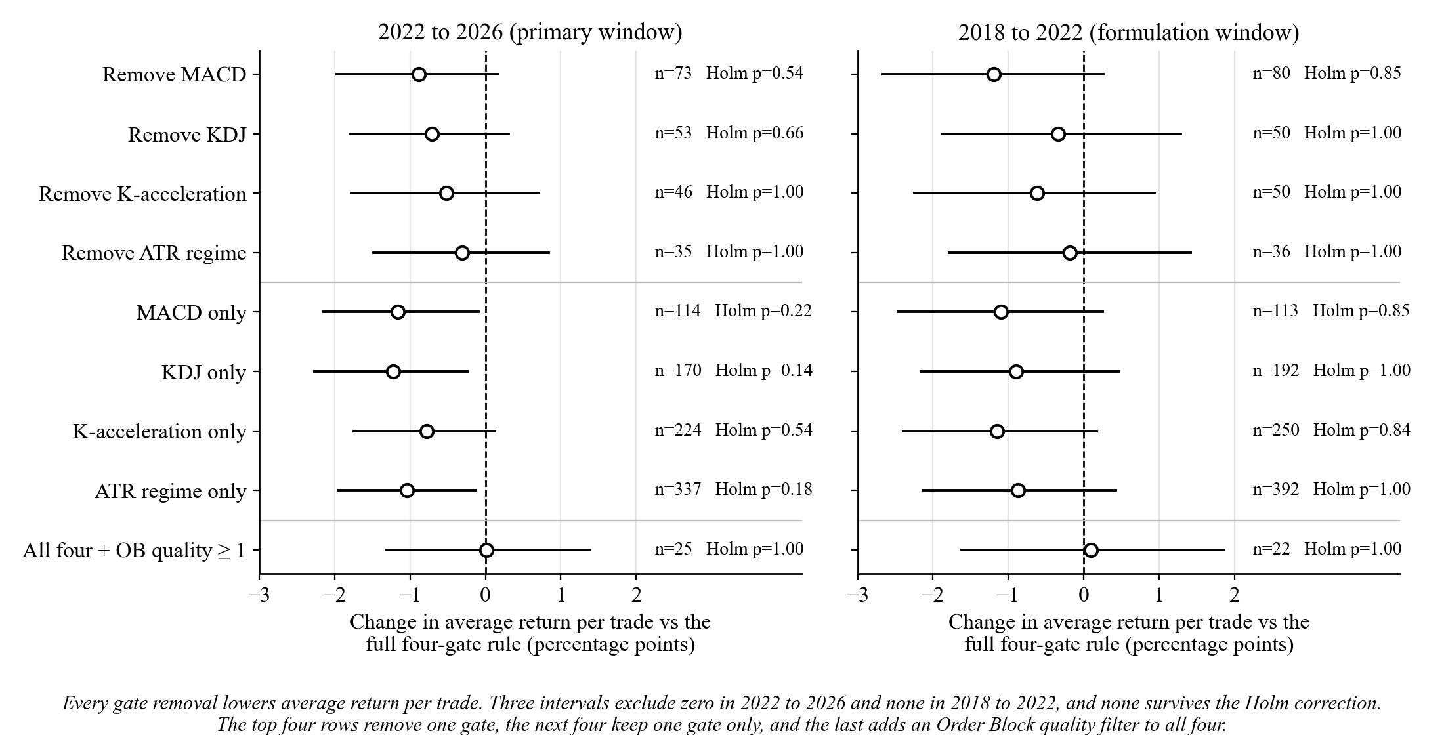
The direction agrees across the two windows: every removal lowers average return per trade in both. The sizes do not agree closely, and no interval in 2018 to 2022 excludes zero. The same nine settings were also run once on the January to August 2026 data used for the forward test, where the full rule made four trades. Every interval there spans zero and every Holm p-value is 1.000, so that run adds nothing either way.

Answers to SOP 5 and Hypotheses H₀₄ and H₁₄
Note. Refer to page for the question being answered.
Answer: no. On 1-hour candles the unchanged rules made 31 trades over 2022 to 2026, only four more than on 4-hour candles, and lost an average of 0.179% per trade after costs. The pre-registered one-sided p is 0.696, so H₀₄ is not rejected. The time-scaled version made 14 trades and also lost money per trade.
Table 15
The Same Rules on 4-Hour and 1-Hour Candles, 2022 to 2026
Version | Trades | Trades per year | Win rate | Avg per trade, gross | Avg per trade, net | Total net | 95% CI, avg net | p, avg net > 0 | Binomial p
4-hour (paper) | 27 | 6.75 | 70.37% | +1.122% | +0.922% | +24.91% | [+0.022, +1.837] | — | 0.0261
1-hour literal (primary) | 31 | 7.75 | 41.94% | +0.021% | −0.179% | −5.55% | [−0.834, +0.566] | 0.696 | 0.8595
1-hour time-scaled ×4 | 14 | 3.50 | 57.14% | −0.075% | −0.275% | −3.86% | [−1.174, +0.647] | 0.722 | 0.3953
Note. Net figures subtract a 0.20% round-trip cost from every trade. For the 1-hour rows, the interval and p-value come from Formula 4 (B = 10,000, seed 20260808); the literal row's p is the pre-registered test of H₀₄, and the time-scaled row's is descriptive. The 4-hour interval is the paper's Formula 1 interval on average return shifted down by the constant 0.20% cost; no average-return p-value was pre-registered for it. Binomial p is the one-sided win-rate test of Table 3, counted on gross wins in every row, as in Table 3.
Figure 10
Trade Frequency and Net Return per Trade on 4-Hour and 1-Hour Candles
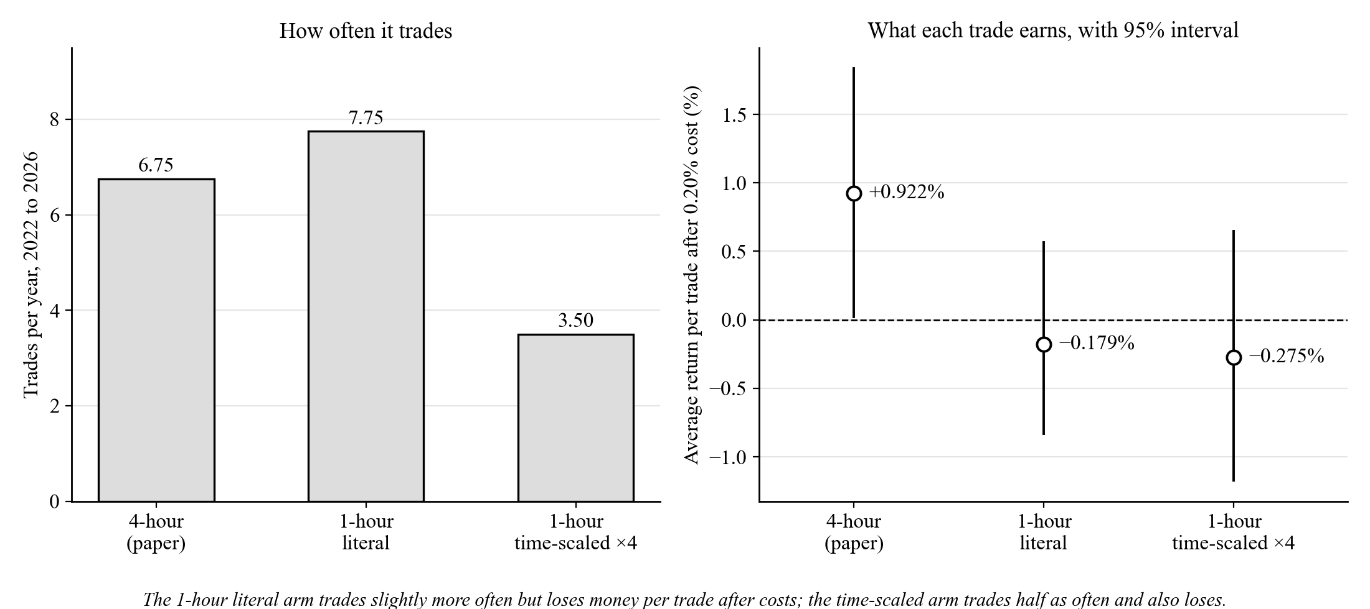
The 1-hour literal version earned 1.101 points less per trade than the 4-hour rules, with a 95% interval of [−2.21, −0.00] and a two-sided p of 0.049. That comparison is descriptive and was not corrected for the second one beside it, −1.198 points for the time-scaled version, p = 0.096. Its win rate, 41.94%, is below a coin flip, and the binomial p of 0.8595 says the same.
The gates do not help on 1-hour candles. Of 1,570 Order Block touches with a valid stop and reward-to-risk over 2022 to 2026, the four gates let 49 through, 3.12%. Picking candidates at random at that same rate, 1,000 times over, matched or beat the gates' average return per trade in 63.3% of runs. Taking every candidate gave 500 trades and −62.71% after costs. On 4-hour candles the same gates lowered return per trade whenever one was removed (Tables 13 and 14), even if not significantly; on 1-hour candles they selected no better than chance.
The result also does not depend on one cost assumption or one stretch of time. At round-trip costs of 0.10%, 0.20%, and 0.30% the literal version's total is −2.45%, −5.55%, and −8.65%. Over 50 random 12-month windows inside 2022 to 2026, its net total was positive in 8% of them, and the time-scaled version's in 44%, mostly because that version often made no trade at all. Both beat buy-and-hold in 16% of windows. The windows overlap heavily, so these shares describe stability, not probabilities.
Table 16
1-Hour Results Outside the Main Window, Including the One-Time Holdout
Window | Version | Trades | Win rate | Avg per trade, net | Total net
2018 to 2022 (formulation) | Literal | 58 | 39.66% | −0.580% | −33.65%
2018 to 2022 (formulation) | Time-scaled | 29 | 55.17% | −0.302% | −8.77%
Jan to Aug 7, 2026 | Literal | 4 | 50.00% | −0.967% | −3.87%
Jan to Aug 7, 2026 | Time-scaled | 5 | 60.00% | +0.141% | +0.71%
Aug 8 to Oct 26, 2026 (holdout) | Literal | 1 | 100.00% | +0.247% | +0.25%
Aug 8 to Oct 26, 2026 (holdout) | Time-scaled | 0 | — | — | +0.00%
Note. Descriptive only. The 2018 to 2022 window is where the rules were formulated. January to August 7, 2026 had already been seen once on 4-hour candles. The holdout ran once, after the main results were committed; Bitcoin rose 23.62% over it.
The holdout produced one literal trade, a long that gained 0.25% after costs, and no time-scaled trade. One trade cannot confirm or contradict anything, so it is reported only because it was pre-registered. The 2018 to 2022 window, where the rules came from, was worse than the main window for both versions.

Conclusions
Over January 2022 to January 2026 the strategy made 27 trades at a 70.37% win rate for +30.31% total net return, and weekly dollar-cost averaging still beat it on final value from equal capital, $22,312.94 against $13,417.77. The defensible use for this rule set is as a small sleeve inside a weekly buying plan, not as a replacement for one.
The return finding holds up directionally. The bootstrap 95% interval on total return excludes zero even though it is wide, and 99.25% of the 10,000 resamples were positive. The win-rate significance is fragile by comparison. It survives the exchange fee alone at p = 0.0261 but not the addition of conservative slippage at p = 0.1239. Both belong to the same answer, and reporting only the first would misrepresent the second.
Return is concentrated. Three trades make up 51.7% of the total, so at this sample size profit rests on a few large outcomes rather than a steady edge in every trade. The positive correlation between holding time and return fits that picture: the large outcomes are the ones the exit rules let run. The edge is also concentrated in bull-trending conditions, at an 85.71% win rate under both regime methods, and is weaker or negative in sideways or bearish conditions under at least one of them.
On the comparison against passive investing, the two results point opposite ways and both must be reported. Head-to-head from equal capital, weekly buying produced roughly 1.66 times the strategy's final capital before costs and roughly 1.75 times after, and no framing changes that. On risk-adjusted shape the strategy was stronger, but it did that while invested 2.63% of the time against 100%. The blended framing is the defensible one: Sharpe and drawdown both improve steadily as the strategy's share rises from 0% to 30% inside a weekly buying plan.
Table 8 is the most direct evidence that the separation between formulation and reported windows is real rather than claimed, because the strategy does worse on the window its rules came from. That should not be overstated. Inspecting charts by eye is weaker separation than a formal held-out split, and the reported window is out-of-sample only for rule building. The four-trade forward test is the only result out-of-sample in both senses, and it is unfavourable.
The two follow-up analyses explain why the strategy trades so rarely and suggest that this is not easy to fix. Each indicator gate removes trades, and every removal tested lowered average return per trade in both windows, although none of those differences is large enough, at this sample size, to be separated from chance after nine tests. Loosening the rule buys trades by giving up return per trade, and the one loosened setting that raised total return, K-acceleration alone, did so with nearly six times the drawdown and reversed on the formulation window.
Moving to 1-hour candles was the other route to more trades, and it failed its pre-registered test. The literal version made 31 trades and lost money per trade after costs, and on that timeframe the four gates chose trades no better than random selection. The rules appear to be tied to the 4-hour scale they were formulated on, rather than being a general description of order flow that works at any speed.
Placed next to the literature this study cites, the headline numbers hold up. Chong and Ng (2008) found MACD produced returns higher than buy-and-hold in most of the cases they tested on the London Stock Exchange. Navarro and Navarro (2023) found only about 35% to 51% of the Philippine stocks they tested were consistently profitable under MACD alone, depending on the setting used. This study's combined strategy, which uses MACD as one confirmation signal among several rather than as a strategy on its own, reached a 70.37% win rate and a +30.31% total net return over 27 trades. On the KDJ side, Wu and Diao (2015) and Dai et al. (2020) both reported statistically significant predictive value for KDJ-family indicators, without building those signals into a full entry-and-exit strategy with real risk management. This study did, and the result sits above the single-indicator figures those studies report. That comparison is not proof the combination itself drove the improvement; Limitation 2 below already flags how much of the return sits in three trades. It is offered as honest context for where these numbers sit next to the prior literature, not as a stronger claim than the data support.

Limitations
1. The study does not model leverage or margin, and reports unlevered returns throughout. The engine checks every exit on candle closes rather than on price movement inside a candle, so a leverage model on top would inherit that limit and report liquidations it cannot actually establish.
2. The sample is small at 27 trades, and return is concentrated in three of them, which together make up 51.7% of the total. Conclusions in either direction are provisional.
3. The separation between the build period and the reported window is real but weaker than a formal held-out split, and no record exists of what rule variants were tried and dropped.
4. The comparison against passive options is descriptive, not inferential. Sharpe and maximum drawdown are each computed once on one realized price path, so no confidence interval or p-value attaches to the difference between arms. A different four-year window could reverse the ordering, as Table 11 already shows in one direction.
5. Two choices are disclosed as assumptions rather than defended as the only correct option: Sharpe assumes a risk-free rate of zero, and the bootstrap is the plain percentile form, not the bias-corrected and accelerated version.
6. Trade frequency is low, at roughly 0.56 trades per month, which limits how fast genuinely forward-looking evidence can build up. The two attempts in SOP 4 and SOP 5 to raise it both lowered return per trade.
7. Structural criteria can read forward without anyone noticing. Two Order Block criteria in this study originally bounded their search loops by the length of the whole dataset instead of by each block's own confirmation candle, so they could read one or two candles that would not have been available yet. That is a real data-leakage bug. A no-lookahead audit found it, and the fix bounds both loops at the confirmation candle with runtime assertions left at those read sites. The fix does not change the 27-trade baseline, because that baseline applies no quality-score filter. Any future study that scans forward from a signal candle can repeat this if the window is not bounded.
8. A reported number can drift from the code that produced it. Two correlation p-values in this study were once reported as below 0.001 when the correct values are about 0.0094 and 0.0113, an overstatement of roughly ten times. Both are corrected here. A figure restated by hand can drift from its source unless every number is traced back to the function that produced it, which is what Appendix A now does.
9. Two correct implementations can disagree. The Python bootstrap here uses 10,000 resamples and the companion dashboard uses 2,000, giving different but individually correct intervals. The gap was traced to the resample count alone, by rewriting the dashboard's random number generator in Python and reproducing its interval exactly. Independent reimplementations must be reconciled explicitly, not silently averaged or quietly dropped.
10. This study's strategy design, code, and statistics were not reviewed by a licensed financial professional or a quantitative-trading practitioner before submission. Verification was internal only, through the regression harness described in Appendix A and the hand recomputation of every headline number in Appendix D. The codebase behind the reported figures will be independently verified by a subject-matter expert in the days after submission, and the results should be read as pending that verification.
11. The gate comparison in SOP 4 switches gates one at a time, so it can miss effects that only appear when two gates act together. The keep-one-gate settings show the other side of that, but not every combination was tested. Its p-values are exploratory even after the Holm correction, because the question was asked after the headline result was known.
12. The time-scaled 1-hour version stretches windows only. Pattern shapes such as the two-candle MACD rise and the three-candle K-acceleration stay in candles, so it is only partly the same strategy in clock time. The 1-hour main window is also the same 2022 to 2026 market the 4-hour rules were reported on, and the only fully unseen 1-hour data, the holdout, produced one trade.
13. A machine-learning trade filter was also tested under the same pre-registration as the SOP 4 gate comparison. It did not beat a model trained on shuffled labels (one-sided p = 0.378) and is not reported as a finding of this paper. Its full write-up is kept with the code so that the test is on record.

Delimitations
1. This study covers one asset only, BTC/USDT. No other cryptocurrency or trading pair was tested.
2. It covers two timeframes: 4-hour candles for every primary result, and 1-hour candles for the pre-registered test in SOP 5. Slower timeframes, and faster ones below 1 hour, were not tested.
3. Three fixed windows were used: January 2018 to January 2022 to build the rules, January 2022 to January 2026 as the primary reported window, and January to July 2026 as a forward test. The 1-hour test in SOP 5 adds a one-time holdout from 2026-08-08 to 2026-10-26. No other split of history was tried.
4. No leverage or margin is modeled anywhere in this study. All returns reported are unlevered, spot-only returns.
5. All price data comes from Binance. No other exchange's order book or price feed was used or cross-checked.
6. The indicator set is fixed at MACD, KDJ, ATR, and Smart Money Concepts Order Blocks. No other technical or on-chain indicator was considered or tested.
7. The passive benchmarks are limited to weekly dollar-cost averaging and a single lump-sum buy-and-hold. No comparison is made to other active strategies, managed funds, or professional traders.
8. This is a backtest and a short forward test only. No capital was ever placed in a live or paper trading account.

Summary and Conclusion
A percentile bootstrap of 10,000 resamples put the 95% interval on total return at [+5.99%, +54.99%], which excludes zero, so the return finding holds up directionally in this window. The win-rate significance does not. A realistic 0.20% round-trip cost moves p from 0.0261 to 0.1239, and every stricter scenario moves it further, driven by exactly two marginal trades. Since that is the realistic assumption, the answer this paper carries forward is that H₀₁ is not rejected once costs a real trader would pay are charged.
On the second research question, weekly buying beat the strategy on final value from equal capital while the strategy had the stronger risk-adjusted shape at 2.63% time in market against 100%. On the third, both risk-adjusted measures improved steadily as the strategy share rose from 0% to 30% inside a weekly buying plan, settled descriptively with no p-value attached. The forward test that came after every code change returned −3.45% across four trades. It is too small to settle anything, and it is also the only evidence out-of-sample in both senses.
Two pre-registered follow-up analyses looked for a way to trade more often. Switching off any one indicator gate lowered average return per trade in both windows, with no difference surviving the Holm correction, so H₀₃ is not rejected. Running the unchanged rules on 1-hour candles gave 31 trades with an average loss of 0.179% per trade after costs at a one-sided p of 0.696, so H₀₄ is not rejected, and on that timeframe the gates picked trades no better than chance.
This study therefore shows a historically observed, directionally robust return edge for this rule set on this window, with its win-rate significance shown to be cost-sensitive and its regime concentration stated openly. It does not show that the strategy will stay profitable in future conditions, and the only evidence so far on that question is unfavourable. Future work should keep collecting genuinely forward-looking trades at the strategy's natural frequency, since only forward evidence can settle whether the edge lasts, and should test the same rules on other instruments. Because the 1-hour test failed, any further timeframe should be pre-registered and tested on candles that come after 2026-10-26, since no unseen data from before that date remains.

References
Arena, C. M. R., Batac, A. A. S., Religioso, A. M. A., Magbata, E. V. S., & Mandigma, M. B. S. (2023). Influences on the stock market investing of tertiary students in the National Capital Region, Philippines. Review of Integrative Business and Economics Research, 12(2), 148–166.
Bangko Sentral ng Pilipinas. (2022). 2021 financial inclusion survey: Topline report. https://www.bsp.gov.ph/Inclusive%20Finance/Financial%20Inclusion%20Reports%20and%20Publications/2021/2021FISToplineReport.pdf
Bessembinder, H., Panayides, M., & Venkataraman, K. (2009). Hidden liquidity: An analysis of order exposure strategies in electronic stock markets. Journal of Financial Economics, 94(3), 361–383. https://doi.org/10.1016/j.jfineco.2009.02.001
Biais, B., Glosten, L., & Spatt, C. (2005). Market microstructure: A survey of microfoundations, empirical results, and policy implications. Journal of Financial Markets, 8(2), 217–264. https://doi.org/10.1016/j.finmar.2004.11.001
Brolley, M., & Cimon, D. A. (2020). Order-flow segmentation, liquidity, and price discovery: The role of latency delays. Journal of Financial and Quantitative Analysis, 55(8), 2555–2587. https://doi.org/10.1017/S002210901900067X
Chong, T. T.-L., & Ng, W.-K. (2008). Technical analysis and the London stock exchange: Testing the MACD and RSI rules using the FT30. Applied Economics Letters, 15(14), 1111–1114. https://doi.org/10.1080/13504850600993598
Constantinides, G. M. (1979). A note on the suboptimality of dollar-cost averaging as an investment policy. Journal of Financial and Quantitative Analysis, 14(2), 443–450. https://doi.org/10.2307/2330513
Corbet, S., Eraslan, V., Lucey, B., & Şensoy, A. (2019). The effectiveness of technical trading rules in cryptocurrency markets. Finance Research Letters, 31, 32–37. https://doi.org/10.1016/j.frl.2019.04.027
Dai, Z., Dong, X., Kang, J., & Hong, L. (2020). Forecasting stock market returns: New technical indicators and two-step economic constraint method. The North American Journal of Economics and Finance, 53, Article 101216. https://doi.org/10.1016/j.najef.2020.101216
Demirgüç-Kunt, A., Klapper, L., Singer, D., & Ansar, S. (2022). The Global Findex Database 2021: Financial inclusion, digital payments, and resilience in the age of COVID-19. World Bank. https://doi.org/10.1596/978-1-4648-1897-4
Díaz, A., & Escribano, A. (2020). Measuring the multi-faceted dimension of liquidity in financial markets: A literature review. Research in International Business and Finance, 51, Article 101079. https://doi.org/10.1016/j.ribaf.2019.101079
Efron, B., & Tibshirani, R. J. (1993). An introduction to the bootstrap. Chapman & Hall.
Fang, J., Jacobsen, B., & Qin, Y. (2014). Predictability of the simple technical trading rules: An out-of-sample test. Review of Financial Economics, 23(1), 30–45. https://doi.org/10.1016/j.rfe.2013.05.004
Finlay, M., & Zorn, J. (2023). Cost averaging: Invest now or temporarily hold your cash? Vanguard Research. https://corporate.vanguard.com/content/dam/corp/research/pdf/cost_averaging_invest_now_or_temporarily_hold_your_cash.pdf
FINRA Investor Education Foundation, & CFA Institute. (2023). Gen Z and investing: Social media, crypto, FOMO, and family. https://www.finrafoundation.org/sites/finrafoundation/files/Gen-Z-and-Investing.pdf
Holm, S. (1979). A simple sequentially rejective multiple test procedure. Scandinavian Journal of Statistics, 6(2), 65–70. https://www.jstor.org/stable/4615733
LuxAlgo. (2022, October 11). Smart money concepts (SMC) [LuxAlgo] [Pine Script indicator]. TradingView. https://www.tradingview.com/script/CnB3fSph-Smart-Money-Concepts-SMC-LuxAlgo/
Lv, T., Hao, Y., Hao, Y., & Shen, C. (2017). K-line patterns' predictive power analysis using the methods of similarity match and clustering. Mathematical Problems in Engineering, 2017, Article 3096917. https://doi.org/10.1155/2017/3096917
Magbitang, J. P., Caballero, M., & Bool, N. (2023). Evaluating the impact of financial literacy and awareness to acceptance and attitude towards cryptocurrency of Filipino millennials workforce in the City of Makati. American Journal of Economics and Business Innovation, 2(1), 39–51. https://doi.org/10.54536/ajebi.v2i1.1213
Nakamoto, S. (2008). Bitcoin: A peer-to-peer electronic cash system. https://bitcoin.org/bitcoin.pdf
Navarro, M. M., & Navarro, B. B. (2023). Assessing the long-term performance of MACD strategy in the Philippine stock market: A 12-year review. In Proceedings of the 6th European Conference on Industrial Engineering and Operations Management (pp. 1280–1286). IEOM Society International. https://ieomsociety.org/proceedings/2023lisbon/327.pdf
Politis, D. N., & Romano, J. P. (1994). The stationary bootstrap. Journal of the American Statistical Association, 89(428), 1303–1313. https://doi.org/10.1080/01621459.1994.10476870
Schär, F. (2021). Decentralized finance: On blockchain- and smart contract-based financial markets. Federal Reserve Bank of St. Louis Review, 103(2), 153–174. https://doi.org/10.20955/r.103.153-74
Sharpe, W. F. (1994). The Sharpe ratio. The Journal of Portfolio Management, 21(1), 49–58. https://doi.org/10.3905/jpm.1994.409501
Statman, M. (1995). A behavioral framework for dollar-cost averaging. The Journal of Portfolio Management, 22(1), 70–78. https://doi.org/10.3905/jpm.1995.409537
Svogun, D., & Bazán-Palomino, W. (2022). Technical analysis in cryptocurrency markets: Do transaction costs and bubbles matter? Journal of International Financial Markets, Institutions and Money, 79, Article 101601. https://doi.org/10.1016/j.intfin.2022.101601
Tukey, J. W. (1977). Exploratory data analysis. Addison-Wesley.
United Nations. (2015). Transforming our world: The 2030 agenda for sustainable development (A/RES/70/1). https://sdgs.un.org/2030agenda
Virtanen, P., Gommers, R., Oliphant, T. E., Haberland, M., Reddy, T., Cournapeau, D., Burovski, E., Peterson, P., Weckesser, W., Bright, J., van der Walt, S. J., Brett, M., Wilson, J., Millman, K. J., Mayorov, N., Nelson, A. R. J., Jones, E., Kern, R., Larson, E., … van Mulbregt, P. (2020). SciPy 1.0: Fundamental algorithms for scientific computing in Python. Nature Methods, 17(3), 261–272. https://doi.org/10.1038/s41592-019-0686-2
Wilder, J. W., Jr. (1978). New concepts in technical trading systems. Trend Research.
Wu, M., & Diao, X. (2015). Technical analysis of three stock oscillators testing MACD, RSI and KDJ rules in SH & SZ stock markets. In 2015 4th International Conference on Computer Science and Network Technology (pp. 320–323). IEEE. https://doi.org/10.1109/ICCSNT.2015.7490760

Appendix A

Statistical Provenance of Every Reported Number
Every statistic reported in a numbered table or stated as a headline figure in the Findings can be traced here to the function that produced it and the data that function was given. Function names refer to research_analysis.py unless another file is named. "Baseline 27" means the 27 trades whose entry candle indices are listed in the Findings.
Table A1
Provenance of Every Reported Statistic
Reported value | Where it appears | Producing function | Library or custom | Exact input
8,767 candles; 4-hour uniform spacing | Section B, Figure 2 | Data loader and gap check | Custom | BTCUSDT 4h, 2022-01-01 08:00 to 2026-01-01 08:00, stamps shifted +8h; 8,766 intervals all equal to four hours, no duplicates
Per-trade log for the baseline 27 | Appendix D | Backtest engine export | Custom | Full trade records including the five criterion flags
27 trades, 19 wins, 70.37% | Table 3 | Backtest engine | Custom | Full 8,767-candle series, parameters as in Table 1
p = 0.0261 one-sided; 0.0522 two-sided | Table 3 | binomial_test(), wrapping scipy.stats.binomtest | SciPy | n = 27, k = 19, null p = 0.5
Bootstrap point +30.3065%, CI [+5.9866%, +54.9866%] | SOP 1 subsection | bootstrap_resample(), driven by run_bootstrap_ci() | Custom (Formula 1) | Returns of the baseline 27; B = 10,000; n = 27; seed = 42
Average-return CI [+0.2217%, +2.0365%] | SOP 1 subsection | Same as above | Custom (Formula 1) | Same input
99.25% of resamples positive | SOP 1 subsection | Same as above | Custom (Formula 1) | Same input
Cross-check CI [+7.48%, +54.46%] | SOP 1 subsection | computeOwnBootstrapCI() in the dashboard, using mulberry32() | Custom, independent TypeScript | Same baseline 27; B = 2,000; seed = 42
Regime tables, both methods | Tables 5 and 6 | Regime tagging routine | Custom | Baseline 27, tagged by calendar year and by drawdown from the $69,000 high of 2021-11-10
Pearson r = +0.4907, t = 2.82, p ≈ 0.0094 | SOP 1 subsection | pearson_correlation(), wrapping scipy.stats.pearsonr | SciPy | Hold time in candles versus percentage return; recomputed r = 0.490698, p = 0.009356
Spearman ρ = +0.4797, p ≈ 0.0113 | SOP 1 subsection | spearman_correlation(), wrapping scipy.stats.spearmanr | SciPy | Same input; recomputed ρ = 0.479728, p = 0.011335
Blended-sleeve Sharpe, drawdown | Table 12 | sharpe_ratio() and max_drawdown_pct() | Custom (Formulas 3 and 2) | Blended equity curve, 210 weekly contributions, 2022 to 2026
Three-arm gross figures | Table 9 | run_benchmark_vs_passive() | Custom (Formulas 3 and 2) | Each arm's own equity curve, $10,000 start, annualization matched per arm
Three-arm fee-adjusted figures | Table 10 | Same, fee-adjusted branch | Custom (Formulas 3 and 2) | Round-trip drag per trade for the strategy, one-sided buy markup for the passive arms
Three-arm formulation-window figures | Table 11 | Same, formulation-period branch | Custom (Formulas 3 and 2) | 2018-01-01 to 2022-01-01 window
Six cost scenarios | Table 4 | Fee and slippage sweep, re-calling binomial_test() per scenario | SciPy for each p-value; custom for the cost model | Baseline 27 with each scenario's cost subtracted per trade
Forward test: 4 trades, 25.00%, −3.45% | Table 7 | Frozen backtest pipeline | Custom | BTCUSDT 4h, 2026-01-01 to 2026-07-31
Window comparison, p = 0.2122 / 0.0261 / 0.0407 | Table 8 | binomial_test() per row | SciPy | Each window's own trade set: n = 25, n = 27, n = 56
Backfill check: 27/27 matched, max difference 0.0000000000% | SOP 1 subsection | Regression comparison routine | Custom | 2018-extended run versus locked 2022 to 2026 run
No-lookahead: 180/180 truncation checks | Section F | Truncation-equality audit | Custom | ATR(14), ATR(200), fixed KDJ(9,3,3) recomputed on truncated series
Gate comparison, Tables 13 and 14, Figure 9 | SOP 4 subsection | rule_ablation() in experimental/ml_meta_labeling.py, using diff_of_means_bootstrap() and holm() | Custom (Formulas 5 and 6) | Same candidate stream and exit simulator as the baseline; nine gate settings per window; B = 2,000; results in experimental/results/oos.json
Gate comparison on Jan to Aug 2026 | SOP 4 subsection | Same, lockbox phase | Custom (Formulas 5 and 6) | experimental/results/lockbox.json
1-hour trades, Table 15, Figure 10 | SOP 5 subsection | run_arm() and summarize_1h() in experimental/rules_1h.py; binomial p via the paper's binomial_test() | Custom; SciPy for the binomial p | experimental/data/btcusdt_1h.csv (sha256 ec24028427a9029a…); results in experimental/results_1h/main.json
p = 0.696 and its interval | Table 15 | primary_style_test(), wrapping stationary_block_bootstrap() | Custom (Formula 4) | 31 literal 1-hour net returns in entry order; B = 10,000; L = 3; seed 20260808
Random-filter share 63.3%, 12-month windows, cost levels | SOP 5 subsection | rules_1h.py, main phase | Custom | 1,570 candidates; 1,000 seeds; 50 windows; costs 0.10%, 0.20%, 0.30%
Other windows and holdout, Table 16 | SOP 5 subsection | rules_1h.py, main and holdout phases | Custom | experimental/results_1h/main.json and holdout.json
Note. Every row was recomputed from the exported trade log during final preparation and agreed with the reported figure to the precision printed here.

Appendix B

Source Form of Every Formula Written for This Study
The six formulas below are reproduced in full so a reader can check each exact expression. Formula numbering runs 1 to 6.
Formula 1. Percentile bootstrap confidence interval. Parameters as used: B = 10,000, n = 27, fixed random seed 42, sampling with replacement.
$T^{\left(b\right)}=\sum_{i=1}^{n}{}r_{i}^{\left(b\right)}$
${T‾}^{\left(b\right)}=\frac{1}{n}\sum_{i=1}^{n}{}r_{i}^{\left(b\right)}, b=1,2,…,B$
$CI_{95\%}=\left[Q_{2.5}\left(T^{\left(1\right)},…,T^{\left(B\right)}\right), Q_{97.5}\left(T^{\left(1\right)},…,T^{\left(B\right)}\right)\right]$
Formula 2. Maximum drawdown.
$P_{t}=\max_{u≤t}E_{u}$
$DD_{t}=\frac{E_{t}−P_{t}}{P_{t}}×100$
$MDD=\min_{t}DD_{t}$
Formula 3. Sharpe ratio. Assumes a risk-free rate of zero.
$SR=\frac{R‾}{s_{R}}\sqrt{m}$
Formula 4. Stationary block bootstrap. Parameters as used: B = 10,000, L = round(n^(1/3)), seed 20260808. For each resample: index k₁ is drawn uniformly from 1 to n; for t = 2 to n, with probability 1/L draw kₜ uniformly, otherwise kₜ = (kₜ₋₁ mod n) + 1. Record r̄* = (1/n) Σ r_{kₜ}. p = (number of r̄* ≤ 0) / B; CI = [P₂.₅(r̄*), P₉₇.₅(r̄*)].
Formula 5. Bootstrap difference in means. Parameters as used: B = 2,000, sampling with replacement. Δ* = mean(resample of a, size n_a) − mean(resample of b, size n_b). CI = [P₂.₅(Δ*), P₉₇.₅(Δ*)]; p = min(1, 2 × min(share Δ* ≤ 0, share Δ* ≥ 0)).
Formula 6. Holm adjustment. With p₍₁₎ ≤ … ≤ p₍ₘ₎ and m = 9: p̃₍ᵢ₎ = min(1, max over j ≤ i of (m − j + 1) p₍ⱼ₎).

Appendix C

Complete Trade Log for the Primary Window
Table D1
All 27 Trades, 2022 to 2026 Window
Idx | Side | Entry time | Exit time | Return % | Bars | Exit reason | Dsp | Lrg | FVG | Swp | Vol | q
335 | Short | 2022-02-26 04:00 | 2022-02-27 16:00 | -0.6645 | 9 | Trailing | Y | - | - | - | Y | 2
359 | Short | 2022-03-02 04:00 | 2022-03-04 08:00 | +6.6888 | 13 | ATR move | - | Y | Y | Y | Y | 4
673 | Long | 2022-04-23 12:00 | 2022-04-25 04:00 | -0.3809 | 10 | KDJ reset | Y | Y | - | Y | Y | 4
902 | Short | 2022-05-31 16:00 | 2022-06-01 20:00 | +3.2248 | 7 | ATR move | - | Y | - | - | Y | 2
1050 | Short | 2022-06-25 08:00 | 2022-06-26 00:00 | +0.4433 | 4 | Trailing | - | Y | Y | Y | - | 3
1158 | Long | 2022-07-13 08:00 | 2022-07-13 20:00 | -0.0898 | 3 | Trailing | - | - | - | Y | - | 1
1913 | Short | 2022-11-16 04:00 | 2022-11-18 04:00 | +1.2308 | 12 | Trailing | - | - | - | - | - | 0
2624 | Short | 2023-03-14 16:00 | 2023-03-14 20:00 | -4.6544 | 1 | Stop loss | - | Y | Y | Y | Y | 4
2859 | Long | 2023-04-22 20:00 | 2023-04-23 08:00 | +0.2507 | 3 | KDJ reset | - | Y | - | Y | Y | 3
3100 | Long | 2023-06-02 00:00 | 2023-06-04 04:00 | +0.7689 | 13 | Trailing | - | - | - | - | - | 0
3196 | Short | 2023-06-18 00:00 | 2023-06-20 00:00 | -0.7818 | 12 | KDJ reset | - | Y | Y | - | - | 2
3859 | Long | 2023-10-06 12:00 | 2023-10-08 16:00 | +0.6263 | 13 | Trailing | - | Y | - | Y | - | 2
3947 | Short | 2023-10-21 04:00 | 2023-10-22 00:00 | -1.6044 | 5 | Stop loss | - | Y | - | Y | Y | 3
4455 | Long | 2024-01-13 20:00 | 2024-01-15 00:00 | -1.1458 | 7 | KDJ reset | - | Y | Y | - | Y | 3
5800 | Short | 2024-08-25 00:00 | 2024-08-27 16:00 | +2.7933 | 16 | ATR move | - | Y | Y | - | - | 2
5825 | Long | 2024-08-29 04:00 | 2024-08-30 00:00 | +0.3779 | 5 | Trailing | - | - | Y | Y | Y | 3
6040 | Long | 2024-10-04 00:00 | 2024-10-06 08:00 | +1.3806 | 14 | KDJ reset | Y | - | - | - | - | 1
6109 | Short | 2024-10-15 12:00 | 2024-10-16 00:00 | -2.0284 | 3 | KDJ reset | - | Y | - | Y | Y | 3
6366 | Long | 2024-11-27 08:00 | 2024-11-28 00:00 | +4.3634 | 4 | ATR move | - | Y | - | - | Y | 2
6537 | Short | 2024-12-25 20:00 | 2024-12-27 12:00 | +3.4665 | 10 | ATR move | - | Y | Y | - | Y | 3
6991 | Long | 2025-03-11 12:00 | 2025-03-12 20:00 | +1.6338 | 8 | Trailing | Y | Y | Y | Y | - | 4
7109 | Long | 2025-03-31 04:00 | 2025-04-01 20:00 | +3.5088 | 10 | ATR move | - | Y | Y | Y | Y | 4
7938 | Long | 2025-08-16 08:00 | 2025-08-18 00:00 | +0.1196 | 10 | KDJ reset | - | Y | - | - | Y | 2
7964 | Long | 2025-08-20 16:00 | 2025-08-22 20:00 | +2.3789 | 13 | ATR move | - | Y | - | Y | - | 2
8188 | Long | 2025-09-27 00:00 | 2025-09-27 16:00 | +0.1264 | 4 | KDJ reset | - | Y | - | Y | Y | 3
8280 | Long | 2025-10-12 08:00 | 2025-10-14 00:00 | +4.6233 | 10 | ATR move | - | Y | - | Y | - | 2
8596 | Short | 2025-12-04 00:00 | 2025-12-06 00:00 | +3.6503 | 12 | ATR move | - | - | Y | - | - | 1
Note. Return % is the trade's net percentage return. Dsp = displacement, Lrg = large origin candle, FVG = Fair Value Gap, Swp = liquidity sweep, Vol = volume expansion. Idx is the entry candle index. Bars is the holding period in 4-hour candles, so each exit time equals its entry time plus four hours times the Bars value. Exit reason is the first exit condition satisfied under the priority order in Figure 5. q is the sum of the five criterion flags.
Checks a reader can run on this table. The Return column holds 19 positive values out of 27, giving the 70.37% win rate. Those 27 values sum to +30.3064%, with a mean of +1.1225% and a standard deviation of 2.41%. Of the 27 trades, 9 closed on the ATR-move exit, 8 on the trailing exit, 8 on the KDJ-reset exit, and 2 on the hard stop-loss. No trade in this window closed on the hard take-profit.

Appendix D

Recomputing Every Number by Hand
This appendix exists so a reader with nothing but a calculator and Table D1 can check the paper. Every number below is derived only from those 27 rows. At the end is a short list of the numbers that cannot be checked this way, and what data would be needed to check them.
E1. Win rate, total return, average, and standard deviation
Win rate. Count the positive values in the Return % column. There are 19, and 19 ÷ 27 = 0.703703, so 70.37%. Total net return. Add all 27 values: +30.3064%, reported as +30.31%. Average return per trade. 30.3064 ÷ 27 = 1.12246, so +1.1225%. Standard deviation. Subtract 1.1225 from each return, square each result, add them, divide by 26, and take the square root. This gives 2.4101, reported as 2.41%. The divisor is 26, not 27, because this is the sample standard deviation.
E2. The binomial p-value
The one-sided exact p-value is the sum of nine terms divided by 2 to the power 27. The denominator is 2²⁷ = 134,217,728. The nine numerators are the binomial coefficients for k from 19 to 27.
Table E1
Binomial Coefficients Needed for the Table 3 p-Value
k (wins) | 27 choose k | k (wins) | 27 choose k
19 | 2,220,075 | 24 | 2,925
20 | 888,030 | 25 | 351
21 | 296,010 | 26 | 27
22 | 80,730 | 27 | 1
23 | 17,550 | Total | 3,505,699
Note. 3,505,699 ÷ 134,217,728 = 0.026119, which is the p = 0.0261 in Table 3. The two-sided value is twice this, 0.0522.
The same method gives the other two p-values in Table 4. For 17 wins, add the coefficients for k = 17 and k = 18, which are 8,436,285 and 4,686,825, to the 3,505,699 above, giving 16,628,809, and 16,628,809 ÷ 134,217,728 = 0.12389, which is p = 0.1239. For 15 wins, add the coefficients for k = 15 and k = 16, which are 17,383,860 and 13,037,895, giving 47,050,564, and 47,050,564 ÷ 134,217,728 = 0.35055, which is p = 0.3506.
E3. Final capital from $10,000
The Total return column of Table 9 adds the 27 returns. The Final capital column compounds them. To compound, divide each return by 100, add 1, and multiply all 27 results together. That product is 1.341777, so the compounded return is +34.18% and $10,000 × 1.341777 = $13,417.77. For the net-of-cost row in Table 10, subtract 0.20 from each return first, then compound the same way. The product is 1.271900, giving +27.19% and $12,719.00. The paper reports $12,719.01; the one-cent gap comes from Table D1 rounding each return to four decimals while the engine carries more.
E4. Time in market
Add the Bars column of Table D1. The total is 231 candles held. The window has 8,767 candles, and 231 ÷ 8,767 = 0.026349, which is the 2.6349% in the note to Table 9, reported as 2.63%.
E5. The calendar regime table
Table 5 splits the same 27 trades by the year of the entry time in Table D1. Nothing else is needed.
Table E2
Rebuilding Table 5 from Table D1
Year | Trades | Wins | Win rate | Sum of returns | Share of +30.3064
2022 (indices 335 to 1913) | 7 | 4 | 4 ÷ 7 = 57.14% | +10.4525 | 10.4525 ÷ 30.3064 = 34.5%
2023 (indices 2624 to 3947) | 6 | 3 | 3 ÷ 6 = 50.00% | −5.3947 | −5.3947 ÷ 30.3064 = −17.8%
2024–2025 (indices 4455 to 8596) | 14 | 12 | 12 ÷ 14 = 85.71% | +25.2486 | 25.2486 ÷ 30.3064 = 83.3%
Note. The three rows use all 27 trades: 7 + 6 + 14 = 27, and 10.4525 − 5.3947 + 25.2486 = +30.3064.
E6. The three-trade concentration
Take the three largest values in the Return % column: +6.6888, +4.6233, and +4.3634. They add to +15.6755, and 15.6755 ÷ 30.3064 = 0.51723, which is the 51.7% quoted in the Conclusions and the Limitations.
E7. The six cost scenarios
Each row of Table 4 subtracts one fixed cost from all 27 returns, then recounts. Because the cost is the same for every trade, the new total is simply the old total minus 27 times the cost. A trade flips from winner to loser when its return is smaller than the cost.
Table E3
Rebuilding Table 4 from Table D1
Round-trip cost | New total = 30.3064 − (27 × cost) | Trades below the cost | New wins | Win rate
0.00% | 30.3064 − 0 = +30.3064 | none | 19 | 70.37%
0.10% | 30.3064 − 2.70 = +27.6064 | none | 19 | 70.37%
0.14% | 30.3064 − 3.78 = +26.5264 | 7938, 8188 | 17 | 62.96%
0.20% | 30.3064 − 5.40 = +24.9064 | 7938, 8188 | 17 | 62.96%
0.24% | 30.3064 − 6.48 = +23.8264 | 7938, 8188 | 17 | 62.96%
0.40% | 30.3064 − 10.80 = +19.5064 | 2859, 5825, 7938, 8188 | 15 | 55.56%
Note. The smallest positive return in Table D1 is +0.1196 at index 7938, then +0.1264 at 8188, +0.2507 at 2859, and +0.3779 at 5825. That ordering decides which trades flip at each cost level. The p-value for each row comes from E2.
E8. The correlation and its t-value
Pearson's r uses the Bars column and the Return % column of Table D1. The mean of Bars is 231 ÷ 27 = 8.5556 candles and the mean of Return % is 1.1225. For each trade, multiply the two differences from their means and add the 27 products. Divide that by the square root of the sum of squared Bars differences times the sum of squared return differences. The result is r = 0.490698, reported as +0.4907. The t-value follows from r alone:
$t = r × \sqrt{n − 2} ÷ \sqrt{1 − r^{2}}$
$t = r × \sqrt{25} ÷ \sqrt{1 − 0.2408}$
$t = 2.4535 ÷ 0.8713 = 2.82$
with df = n − 2 = 25. Spearman's ρ uses the same two columns after replacing each value with its rank, giving ρ = 0.479728, reported as +0.4797. The p-values attached to both, 0.0094 and 0.0113, come from SciPy and are not hand-computable; see E10.
E9. Dataset and schedule arithmetic
Candle count. 1,461 days × 6 candles per day = 8,766 intervals, plus the final stored row = 8,767 rows. Weekly contribution. $10,000 ÷ 210 weeks = $47.6190; for the 2018 window, $10,000 ÷ 209 = $47.8469. Annualization factor for 4-hour bars. 6 × 365.25 = 2,191.5; for weekly figures it is 52. Combined window in Table 8. 25 + 27 + 4 = 56 trades; 15 + 19 + 1 = 35 wins, and 35 ÷ 56 = 62.50%; returns +21.82 + 30.31 − 3.45 = +48.68%.
E10. What cannot be checked by hand, and why
The following numbers need data or computation that Table D1 does not contain. They are listed so no reader assumes an omission.
• The bootstrap interval [+5.9866%, +54.9866%], the point estimate +30.3065%, the average-return interval, and the 99.25% figure. These need 10,000 random resamples. The inputs, the 27 returns and the seed 42, are both given, but the arithmetic is not hand-scale.
• The Sharpe ratio and maximum drawdown in Tables 9 through 12. These are computed from full equity curves, one value per bar or per contribution week, not from trade returns. The construction is fully specified in Section E, but the underlying price series is needed to rebuild them.
• The exact p-values on the two correlations, 0.0094 and 0.0113. The r and ρ values themselves are hand-computable, as is the t-value; converting t to a p-value requires the t-distribution.
• Table 6, the drawdown-from-high regime split. Assigning each trade needs Bitcoin's price history relative to the $69,000 high of 2021-11-10. The counts and sums can still be checked: 12 + 8 + 7 = 27, and −1.63 + 18.89 + 13.05 = +30.31.
• Table 11, the 2018 to 2022 window, and Table 7, the 2026 forward test. These use trade sets that are not printed in this paper.
• Tables 13 to 16 and Figures 9 and 10. They use trade sets that are not printed here, and their intervals and p-values need thousands of resamples. The committed result files named in Appendix A hold every input.
For everything on that list, Appendix A names the exact function and the exact input, so the computation can be repeated by anyone who runs the code.

